M .Kozlowski¹, M. Pelc*
The Schrödinger equation
A History
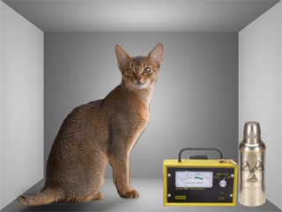

Abstract
The paper is based on the handouts of the student seminars presented by us at the Institute of Physics , Maria Sklodowska-Curie University , Lublin, Poland
At the 2007 120 years elapsed since the born date of the Erwin Schrodinger. The seminars were devoted to the presentation of the history of the Schrodinger equation and its contemporary interpretations. The paper contains the citations of the relevant fragments of the books by JS Bell , S Weinberg and D.Bohm in order to preserve the full contents of the seminars and the discussed material

¹Corresponding author :miroslawkozlowski@aster.pl , www.fuw.edu.pl/~mirkoz

* Post-graduate , Physics Institute, Maria Skłodowska-Curie University, Lublin , Poland

CONTENTS

Intoduction ……………………………………………………………………………3

Chapter 1 The origins of the wave mechanics ……………………………………6

Chapter 2, Relativistic wave mechanics ………………………………………….17

Chapter 3, Interpretations …………………………………………………………26

Chapter 4, Quo vadis quantum mechanics. ?........................................................53

Appendix A Wave Nature of Biomolecules and Fluorofullerenes______________55

INTRODUCTION

In twentieth – century physics, the two main paradigm shift are the theory of relativity and quantum theory. The former caused a major reassessment of the concepts of space and time; the latter challenges our ideas of existance itself.
Examples of seemingly innocuous terms that arise in discussions of quantum theory include system, observable, property physical quantity, measurement, state, causality, determinism. Any serious discussion of such concepts leads at once into deep issues in the general philosophy of science, such as:
- the object matter of scientific investigations;
- the status of theoretical terms and postulated entities;
- the relation of mathematical models to the physical world;
- the question of if and how scientific statement can be verified or falsified;
- the nature of space and time.
Issues of this type lead us to augment our list of innocuous terms with words such as
- realist
- antirealist
To begin with the realism in quantum physics can be stated as follows:
- It is appropriate in quantum theory to say that an individual system possessed values for its physical quantities.
The anti – realist position is characterized as:
- The notion of an individual physical system having or possessing values for all its physical quantities is inappropriate in the context of quantum theory.
In this pedagogical exposure of the Schrödinger equation we present the both interpretations of quantum mechanics.
In introductory Chapter 1 the origins of wave mechanics is presented. Chapter 2 presents the anti – realistic description of wave mechanics by S. Weinberg. Chapter 3 is devoted to the realistic attitude to quantum mechanics by J. S. Bell and D. Bohm. In Chapter 4 the perspective for realistic interpretation of wave mechanics is outlined. Appedix A contains the presentation of the part of Schrodinger Alma Mater Vienna University quantum tradidion.

Introductory note
At the outset of every discussion a physicist must define his symbols and notation. Let it therefore be known that by “he” we mean “he or she”, by “him”,”him or her”,etc. If we are using the traditional language in this talk ,it is solely for the sake of brevity

MK, MP, Lublin2 22 03 07

Chapter1
Origin of the wave mechanics

Basic papers on Schrödinger Wave Mechanics

Schrödinger, E., 1926a, 'Quantisierung ales Eigenwertproblem
(Erste Mitteilung)' Ann. Phys., 79, 361.
Schrödinger, E., 1926b, 'Quantisierung als Eigenwertproblem
(Zweite Mitteilung)' Am. Phys., 79, 489.
Schrödinger, E., 1926d, 'Quantisierung als Eigenwertproblem
(Dritte Mitteilung:)' Ann. Phys., 80, 437.
Schrödinger, E., 1926e, 'Quantisierung als Eigenwertproblem
(Vierte Mitteilung)' Ann. Phys., 81, 109.

1. 1 The mystery
There has always been an intriguing element of mystery about the origin of wave mechanics, in marked contrast to the case of quantum mechanics. The invention of quantum mechanics, starting in the year 1926-27, was the achievement of a number of remarkable physicists having clear ends in view and freely exchanging ideas with each other. Foremost among these were the young contemporaries P. A. M. Dirac (1902-84) W. Heisenberg (1901-76) P. Jordan (1902-) and W. Pauli (1900-58). They had advice from well known senior colleagues including N. Bohr (1885—1962) M. Born (1882-1970) R. H. Fowler(1889-1944) and H. A. Kramers 1894-1952). Although all were strongly independent thinkers, none worked in isolation from the rest. All those named belonged in fact to a Cambridge-Copenhagen-Gottingen circuit. The contemporaneous early development of wave mechanics was far otherwise. This was the achievement of the single physicist E. Schrodinger (1887-1961) working in isolation from other physicists. In the year 1926 he presented its formulation, together with detailed examples of its application, and he demonstrated its unanticipated equivalence to the quantum mechanics advanced by those others.
How came it that this not widely-known, middle-aged Austrian holder of a Swiss professorship, in papers appearing at about the rate of one per month, produced
unheralded a theory that transformed fundamental physics and chemistry? This has been the mystery. Much about Schrödinger's work and thought has been recorded by himself, by colleagues after his death, and by historians of science; some is listed in the references at the end of this notice. By far the most extensive study to the end of 1926 is that by Mehra and Rechenberg in these two books, here quoted as MR. That is history; this review is an attempt to interpret some of it; and is intended to be a tribute to the immense labours of those authors.
As one who knew Schrodinger personally—although our direct contacts were all within the years 1940-42, I seek to display the features in the history that appear best to help to answer the question here posed, and then to see whether the mystery is dispelled. Most of the factual historical information is from MR; opinions regarding significance are those of the reviewer.
1.2. Main elements contributing to Schrödinger's production of wave mechanics
Three principal strands in Schrödinger's mathematical-physical education and experience combined together to yield the outcome:
He had a splendid schooling in 'the more sophisticated schemes of mechanics and the eigenvalue problems of the physics of continua ... just as I would need them later on' (S1935a references to Schrödinger being made in this style; italics throughout are those of the present writer).
Scientifically speaking, Schrödinger grew up in the ethos of the Vienna school of L. Boltzmann in statistical physics. By the time that he reached scientific maturity the predominant relevant interest in this field, inspired by Planck and by Einstein, was in quantum statistics. This led to Schrödinger becoming immersed in fundamental aspects of quantum physics.
Schrödinger's cast of mind caused him to be fascinated by unification in physics, in particular the possible unification of gravitation and electrodynamics, and then in the unification of particle and wave aspects of physical phenomena. As early as 1922 he published (SI922) an unwitting anticipation of L. de Broglie's proposal for a 'wave' quantization of electron orbits that, remarkably, sprang from his study of Weyl's proposal for a unified treatment of gravitation and electromagnetism.
1.3 Contacts with scientists
While Schrödinger had, and sought, no collaborators in the usual sense in his scientific research, he welcomed contacts of a more occasional character. He owned that he seldom had the first word on any question; but he often had the second, arising from his reaction of wanting to criticize, improve upon, and extend what somebody else had initiated (S1935a). Before 1926 he had met eminent contemporaries in the course of his ^fc travels in Germany, and at two notable physics conferences during 1924. He and they enjoyed subsequent scientific correspondence. Thus, he gained stimulation from, in particular, A. Einstein (1879-1955) A. Sommerfeld (1868-1951) P. Debye (1884-1966) and H. Weyl (1885-1955). The last two were specially significant since they were working in E.T.H. in Zurich while Schrödinger was in the University there from 1921 to 1927.

1.4 De Broglie matter-wane conjectures
Experience shows the transmission of electromagnetic radiation to exhibit characteristics of a wave phenomenon. Other experience shows it to possess characteristics of particle motion (in the phenomena attributed to 'light-quanta' or 'photons'). Experience shows the transmission of electric charge to exhibit characteristics of particle motion (in phenomena attributed to electrons, etc.). de Broglie suggested that it might also possess characteristics of a wave phenomenon. If so, the particles would have to be regarded as quanta associated with the waves. This suggests a relation between wavelength and particle energy, de Broglie systematically explored possible consequences of such a concept. In particular, he inferred that the length of the Bohr (closed) electron orbit for a quantum state of an atom would be an integral multiple of the wavelength for the energy of that state, this multiple being the (principal) quantum number of the state.
Apparently Schrödinger first learned of these ideas from a mention in a paper published in 1925 by Einstein (see MR page 412). He first had an opportunity to read de Broglie's own account in October of that year. Features that evidently struck chords of sympathy in Schrödinger's mind were:
(a) The notion of this new unification in physics, and of particle and wave concepts in general.
A possible realization here of the correspondence between mechanics and optics recognized in Hamilton's analytical dynamics.
The similarity between Schrödinger's own work of 1922 and de Broglie's treatment of atomic quantum states.
The treatment offered the possibility of a physical understanding of the occurrence of quantum states and of the origin of quantum numbers. This was in consonance with Schrödinger's early acquaintance with, and subsequent exploitation of, the mathematics of eigenvalues; it contrasted with the introduction of quantum numbers by edict in the 'old' quantum theory.
1.5 Zurich Colloquium
Despite all these reasons why de Broglie's work should appeal to Schrödinger his mere reading the work did not immediately stimulate him to pursue the subject for himself. I think this was because de Broglie's presentation lacked analytical mathematical formulation.
The subject then happened to arise in conversation between Schrodinger and Debye. Both professed not to have understood the work. Result: Debye proposed that Schrödinger should give a colloquium about it! This he did in November or December 1925 as one of their current joint E.T.H.-University series. Not for the only time in history did the call to explain to an audience something that the speaker had not understood transform it into his major concern. That colloquium denoted a turning-point in the history of physical science, simply because it made Schrödinger look for a way of deriving a wave equation to be associated with a given physical system.
De Broglie, in developing and applying his matter-wave conjecture, had employed 'geometrical' or 'pictorial' methods. He proposed no way to write down a wave equation for any of the physical systems he discussed, so that he could obtain his waves as appropriate solutions of the equation. For Schrödinger, a 'proper' theory would start by formulating such an equation.
It was manifestly Schrödinger's particular style of working that then determined the ensuing course of history. He always kept himself busy with physics and, as we have noted, he had certain enduring channels of thought and interest. But he never for long worked to a deliberately planned programme (S1935, page 87). When he had done all that seemed interesting and feasible on one topic, he would switch to the most attractive challenge next on offer. Towards the close of the year 1925, Schrödinger was evidently due for a switch; happily he took up the challenge to find a wave equation.
The outcome was the invention of wave mechanics in Schrödinger's sequence of famous papers of the year 1926. These were soon collected and republished, in book form, first in the original German and then in an English translation (S1927, 1928).
1.6. Finding a wave equation
How did Schrödinger obtain his equation? Little of the answer is to be learned from the papers themselves. However there survives a short Memorandum which he is inferred to have written in December 1925. Along with a brief record of what he later told Dirac this gives some insight; MR refer also to a research notebook of Schrödinger's of some 70 pages, but this seems to comprise little more than drafts of material for the published papers.
Guided by the wave equation that would be satisfied by de Broglie plane waves associated with an electron in uniform motion in an inertial frame, Schrodinger conjectured a form for the wave equation for the case of an electron in a Coulomb field. He attempted to determine the eigenvalues. These turned out to be in disagreement with accepted energy quantum states of the hydrogen atom. This brought Schrödinger to the verge of abandoning the subject.
That discredited treatment had purported to be relativistic. As what appears to have been an inspired afterthought, Schrödinger took the trouble to see what he could make of a non-relativistic treatment. Again the wave equation seems to have been a matter of conjecture. Having got it, by whatever means, he found he could evaluate the eigenvalues; he found them to reproduce the accepted observational results for the hydrogen atom. He resolved to publish.
As soon afterwards appeared from the work of Dirac, the attempted relativistic treatment had given wrong results because it had not taken account of electron spin.
1.7 The papers of 1926
. WAVE MECHANICS
The Editor of Annalen der Physik received Schrödinger's paper Quantisierung als Eigenwertproblem (Erste Mit-teilung) on 27 January 1926; it was published on 13 March. Schrödinger began with the Hamilton-Jacobi equation for an electron (non-relativistic, non-radiating, non-spinning) moving in a Coulomb field of force; he used this somehow to suggest a variational problem; he asserted, "The quantum conditions are replaced by this variation problem'. There emerged a wave-function; he derived the acceptable eigenvalues mentioned above. The eigensolutions appeared in a rather nebulous manner, no use being as yet proposed for them.
The wave equation that thus made its appearance was indeed the first example of what was due to be the standard equation of wave mechanics. It is a waste of time trying to understand how Schrodinger purported to obtain it, as he himself indicated in his next paper. This Zweite Mitteilung was received on 23 February 1926 and published on April 6. He begins again with a mention of the general correspondence that exists between the Hamilton-Jacobi differential equation for a problem in mechanics and the 'allied' wave equation. He produces the standard wave equation of wave mechanics for any system specified by a given Hamiltonian. As regards one of the steps that had appeared to play an essential part in obtaining the wave equation in the first paper he now describes it as being 'in itself unintelligible', and another as 'equally incomprehensible'!
It has to be said then that the proceeding in the second paper, which must rank as the foundation paper of wave mechanics, is no great improvement in lucidity over that in the first.
From the discussion in paragraphs 1-3 of this review it may be claimed that there remains little mystery about what led Schrödinger to do what he did, even if it all involved a whole train of unusual and unlikely circumstances. But how in the end he actually did it, how he wrote down the general form of the wave equation, the be-all and end-all of the entire story—that is still mysterious. It seems impossible now to do anything better than guess that it came from lucky guesses stimulated by the particular circumstances of the moment, his particular scientific background, and his very particular scientific genius. At the time he appeared to believe that he was in some way thinking along lines laid down by Hamilton.
In brief, the main outcome of the first two papers in the series (S1926a,b) was the Schrödinger wave equation for the wavefunction Ψ for any given system,
H(q,p) φ =E φ
in a familiar shorthand, where H(q,p) is the classical Hamiltonian of the system, and H(q,p) - E = 0 is the classical energy integral. The fourth (S1926e) gave the more general equation for the time-dependent wave-function Ψ, namely
ih =H(q,p} Ψ
φ, or Ψ. Schrödinger himself did not write the wave equation explicitly in terms of the Hamiltonian H. I do not know who first did this. But when other workers saw this recipe for getting these equations they were convinced that what they needed was this or nothing. And they were going toof wave mechanics' by Schrödinger is that written by Whittaker (1953, Chapter IX). Whittaker's own intimate familiarity with classical analytical dynamics evidently gave him special insight into the working of Schrödinger's mind in arriving at his wave equation. On his part, Schrödinger (SI926b) had referred to Whittaker's (1904) classic treatise on the subject, which had also been of crucial assistance to Dirac in his formulation of quantum mechanics. Also, having mentioned Courant and Hilbert (1924), one should add that Whittaker's treatise Modern Analysis, in the guise of Whittaker and Watson (1927), came to serve English-reading students of wave mechanics in much the way in which Courant and Hilbert served German-readers.
When this notice was being made ready for the printer there came to hand Professor Walter Moore's impressive work Schrödinger, life and thought (Moore 1989). This appears likely to be the most comprehensive 'life' that will ever be written about Schrödinger. As regards simply his science, however, by their nature the MR books provide much more detailed information about his work and that of his contemporary physicists. It is hoped that the brief sketch given here of just one theme in the history may serve as some guide to readers of any such so vastly more substantial accounts.
1.8. Events and dates
Until the winter 1920-21 Schrödinger had little contact with quantum theory and workers in that field. In order to see the circumstances under which Schrödinger became involved, and to help to put the foregoing account into perspective the following 'time-table' may be of assistance.
Events relevant to Schrödinger's concern with quantum theory, leading up to invention of wave mechanics: Sommerfeld and W. Pauli.
1920 Spent spring semester in post in University of Jena under Max Wien.
1920-21 Winter semester spent as Ausserordenlich Professor in Technische Hochschule, Stuttgart, started correspondence with N. Bohr and H. A. Kramers.
1921 Spring semester spent as Professor in University of Wrocław, colleague R. Ladenburg involved in quantum physics.
1921 October: became Professor of Theoretical Physics, University of Zurich,
1922 October: submitted paper (S1922) 'On a notable property of quantised orbits of a single electron. December: gave inaugural lecture (S1929 chapter VI) 'What is a law of Nature?'
1924 April: attended Solvay Conference in Brussels, met in particular P. Debye and H. A. Lorentz.
1924 September: attended Naturforscherversammlung in Innsbruck, met in particular Max Born, P. P. Ewald, H. A. Kramers, A. Sommerfeld, W. Pauli, A. Einstein and M. Planck. Correspondence with Sommerfeld ensued.
1924 November: Sommerfeld sent Atombau 4th edition. Correspondence with Einstein, and read Einstein (1925).
1925 October: read de Broglie thesis on matter- waves.
1925 November-December: gave Zurich colloquium on de Broglie's work, started looking for wave equation.
1926 January: submitted paper (SI926a) 'Quantization as eigenvalue problem I'.
1926 February: submitted paper (S1926b) II in series.
1926 March: submitted paper (S1926c) 'On the relation between the quantum mechanics of Heisenberg, Born and Jordan, and that of Schrödinger'.
1926 May and June: submitted papers III, IV in series.
Erwin Fues worked in Zurich as Schrodinger's 'first student'.
1926 October: attended fifth Solvay Conference in Brussels, met de Broglie, both expounded their theories.
1927 Autumn: succeeded Max Planck in Berlin Professorship.
References
Courant, R., and Hilbert, D., 1924, Methoden der Mathematischen
Physik I, (Berlin: Springer). [2. Auflage 1931]. Einstein, A., 1925, 'Quantentheorie des einatomigen idealen Gases', Sitz. bei Preuss. Akad. Wiss, 1924 December, pp. 3-14. Moore, W., 1989, Schrödinger, Life and Thought (Cambridge University Press). Schrodinger, E., 1922, 'Uber eine bemerkenswerte Eigenschaft der Quantenbahnen ernes einzelnen Elektrons' Z. Phys., 12, 13.

Schrödinger, E., 1926a, 'Quantisierung als Eigenwertproblem (Erste Mitteilung)' Ann. Phys., 79, 361.
Schrödinger, E., 1926b, 'Quantisierung als Eigenwertproblem (Zweite Mitteilung)' Am. Phys., 79, 489.
Schrödinger, E., 1926d, 'Quantisierung als Eigenwertproblem (Dritte Mitteilung: Stdrungstheorie)' Arm. Phys., 80, 437.
Schrödinger, E., 1926e, 'Quantisierung als Eigenwertproblem (Vierte Mitteilung)' Ann. Phys., 81, 109.
Schrödinger, E., 1927, Abhandlungen zur Wellenmechanik (Leipzig: Barth), second edition 1928.
Schrödinger, E., 1928, Collected papers on wave mechanics, translation of second German edition (London: Blackie).
Schrödinger, E., 1935a, Les prix Nobel en 1933, Pp. 86-88 (Stockholm: Norstedt).
Schrodinger, E., 1935b, Science Theory and Man (London: Allen and Unwin).
Scott, William T., 1967, Erwin Schrodinger: an Introduction to his Writings (University of Massachusetts Press).
Whittaker, E. T., 1904, A Treatise on the Analytical Dynamics of Particles and Rigid Bodies, fourth edition 1988 (Cambridge University Press).
Whittaker, Sir Edmund, 1953, A History of the Theories of Aether and Electricity. The modem theories 1900-1926 (London: Thomas Nelson).
Whittaker, E. T, and Watson, G. N., 1927, Modern analysis, fourth edition (Cambridge University Press).

Chapter 2
Relativistic Wave Mechanics *

* S.Weinberg, The Quantum Theory of Fields

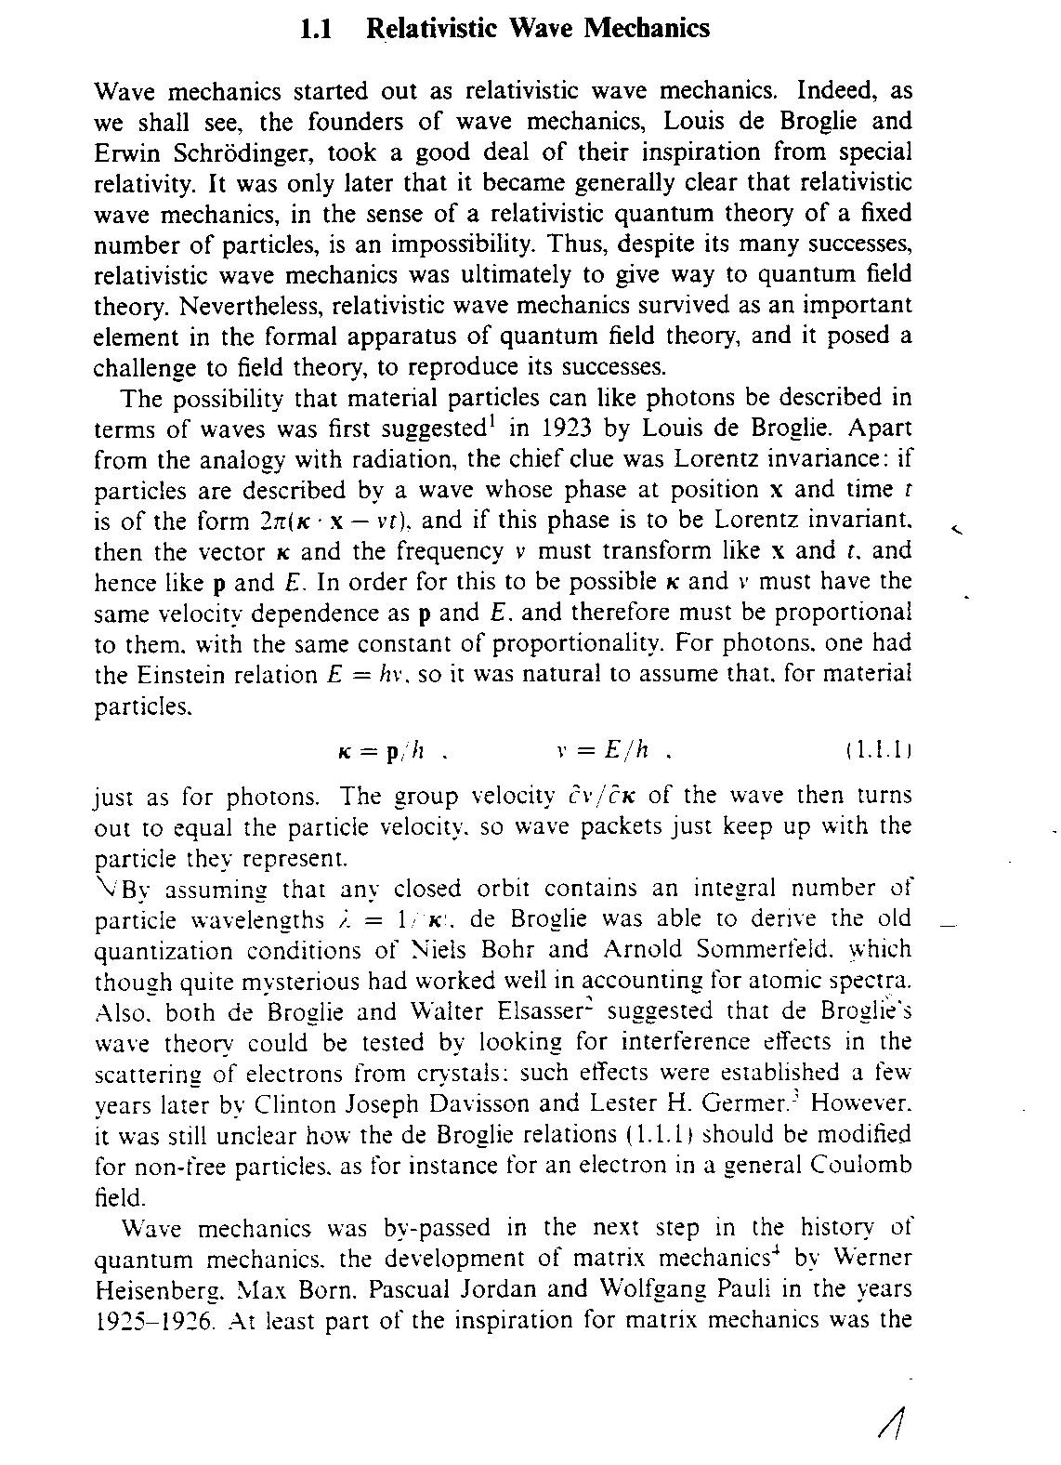
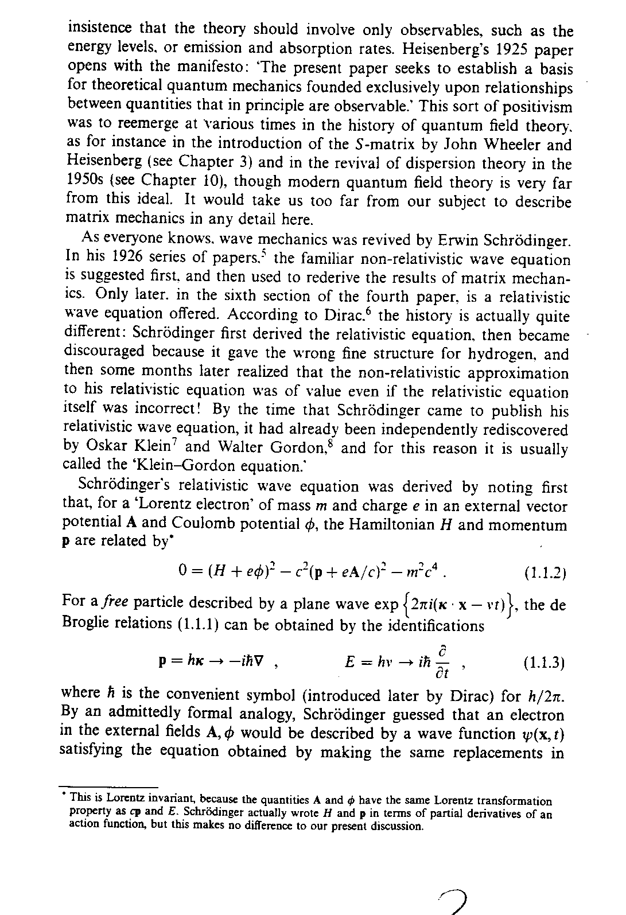
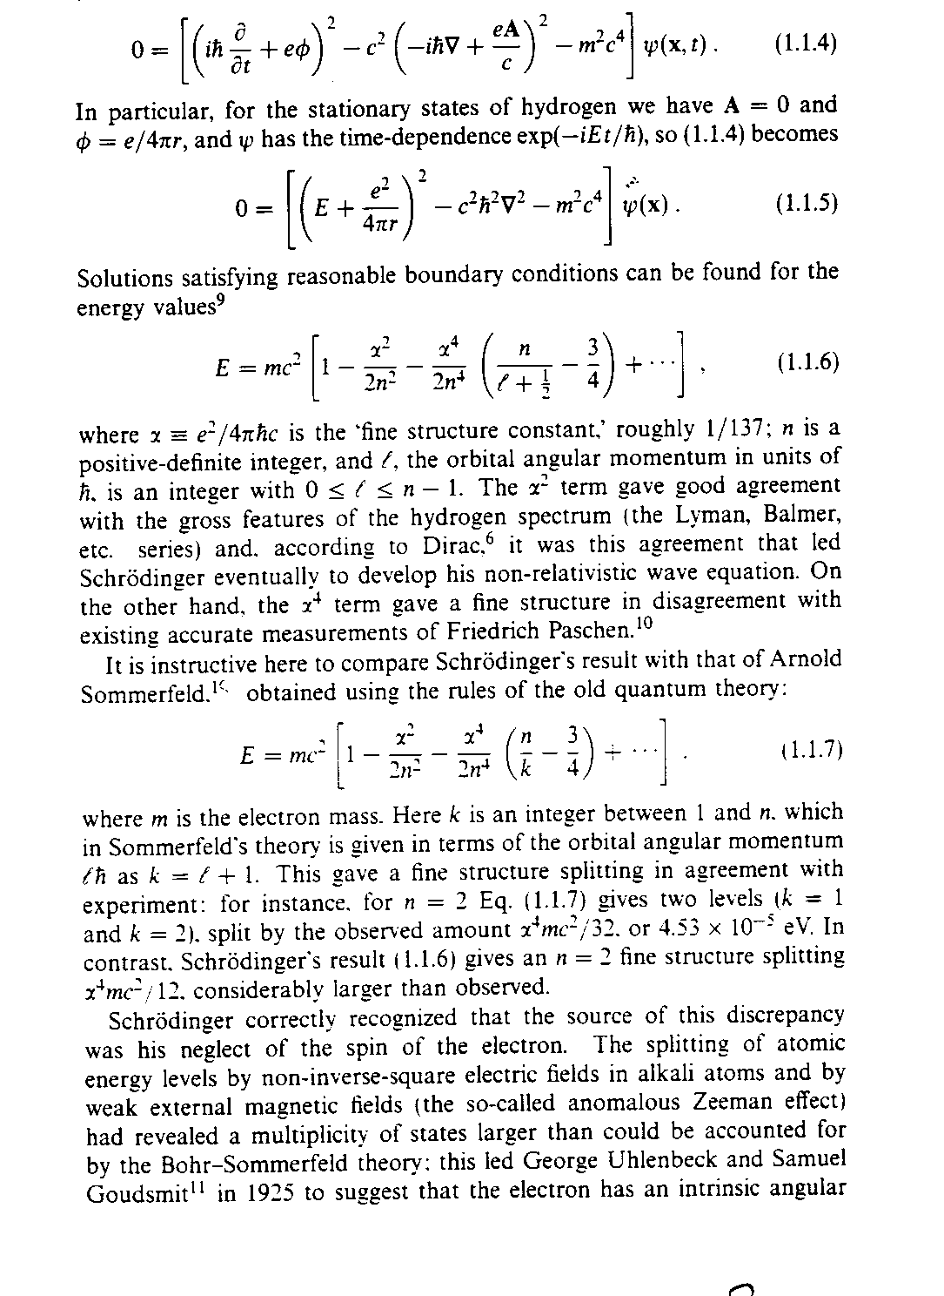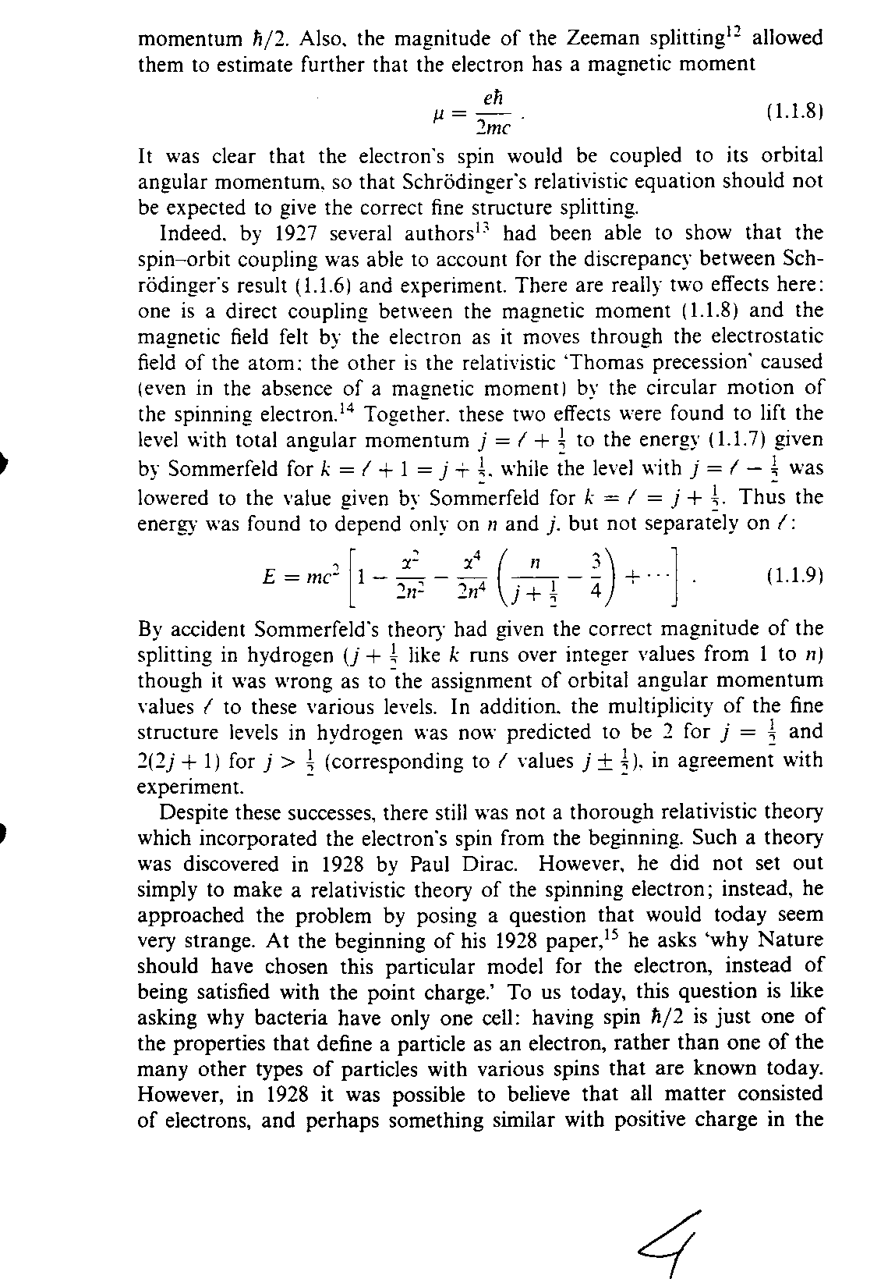
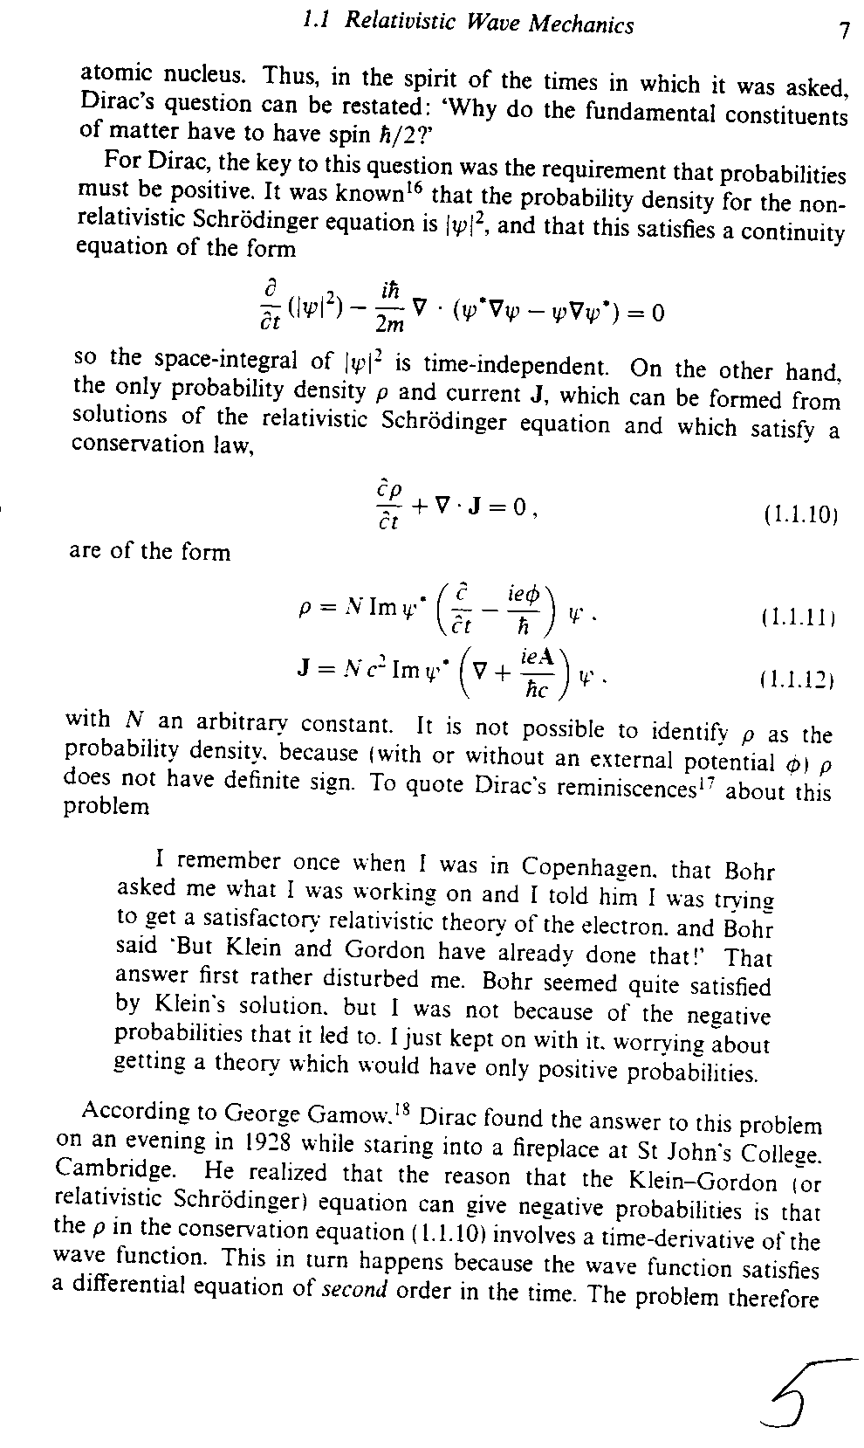
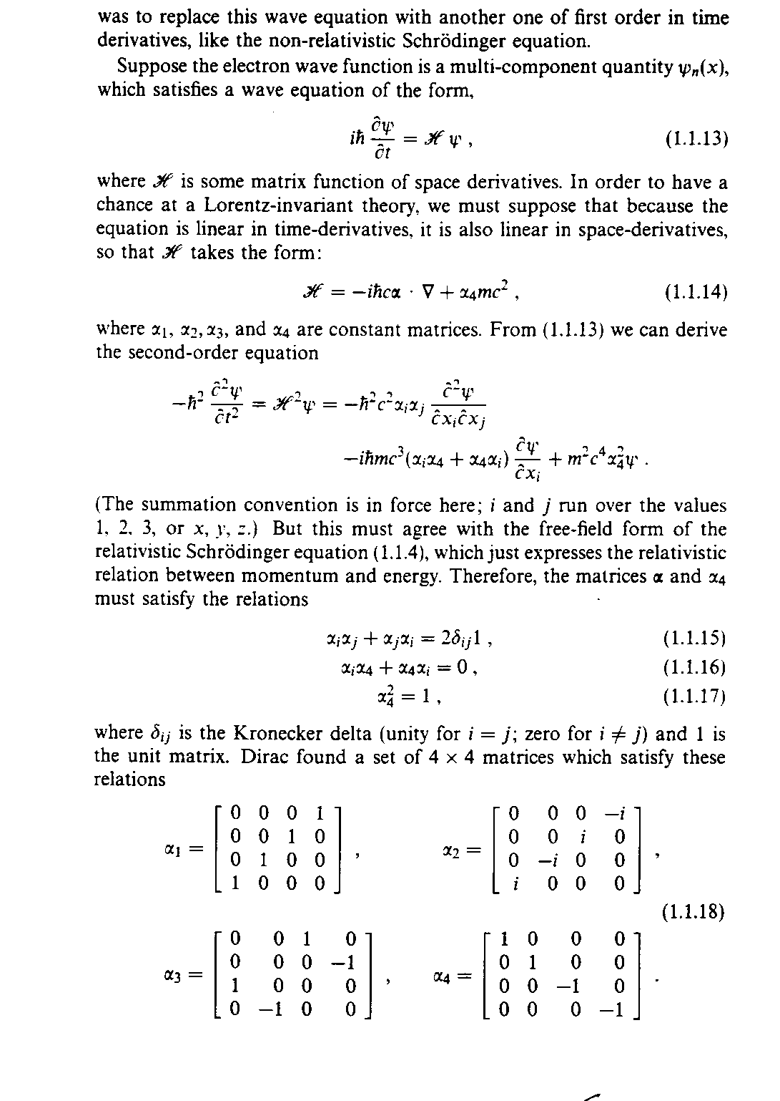
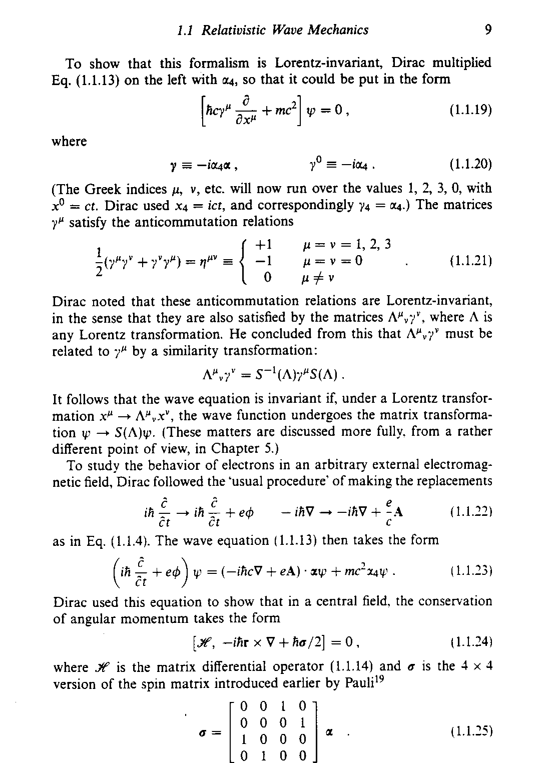
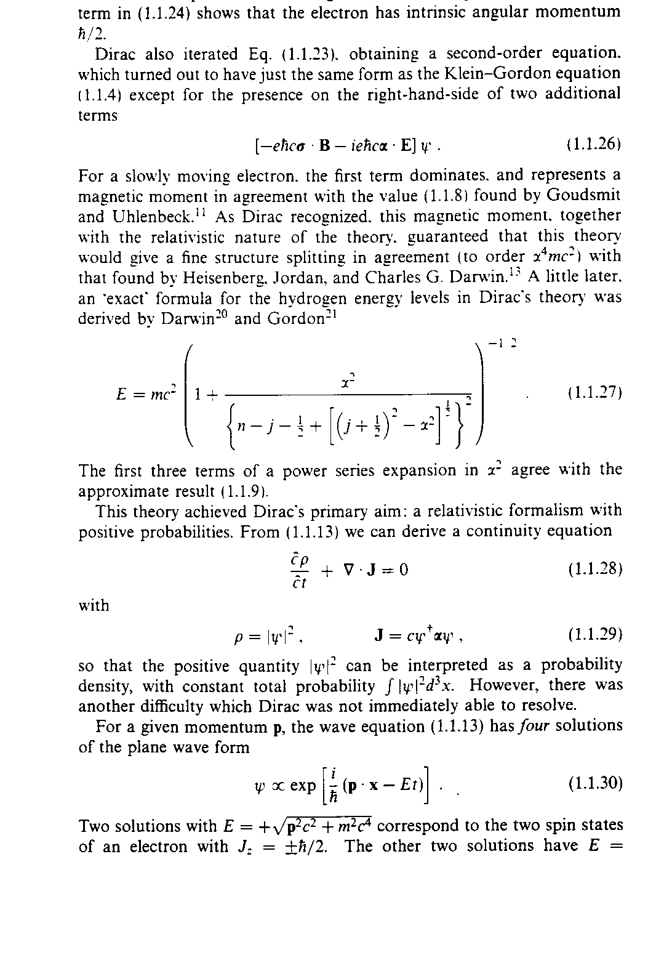

Chapter 3

Interpretations

BELL INTERPRETATION*

*Bell, J. S., Speakable and unspeakable in quantum mechanics, Cambridge University Press, 1989
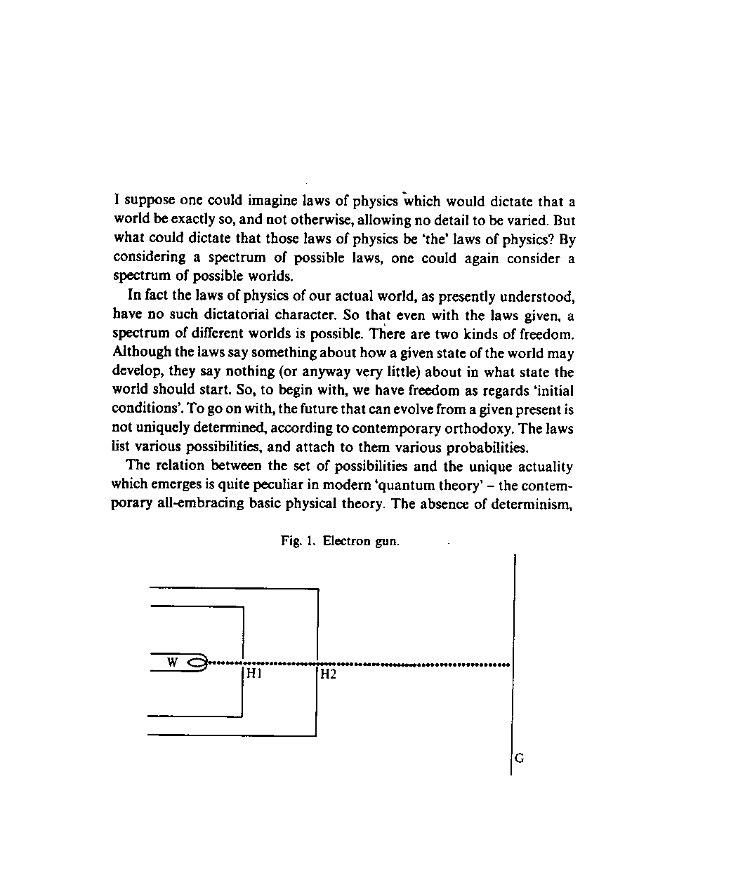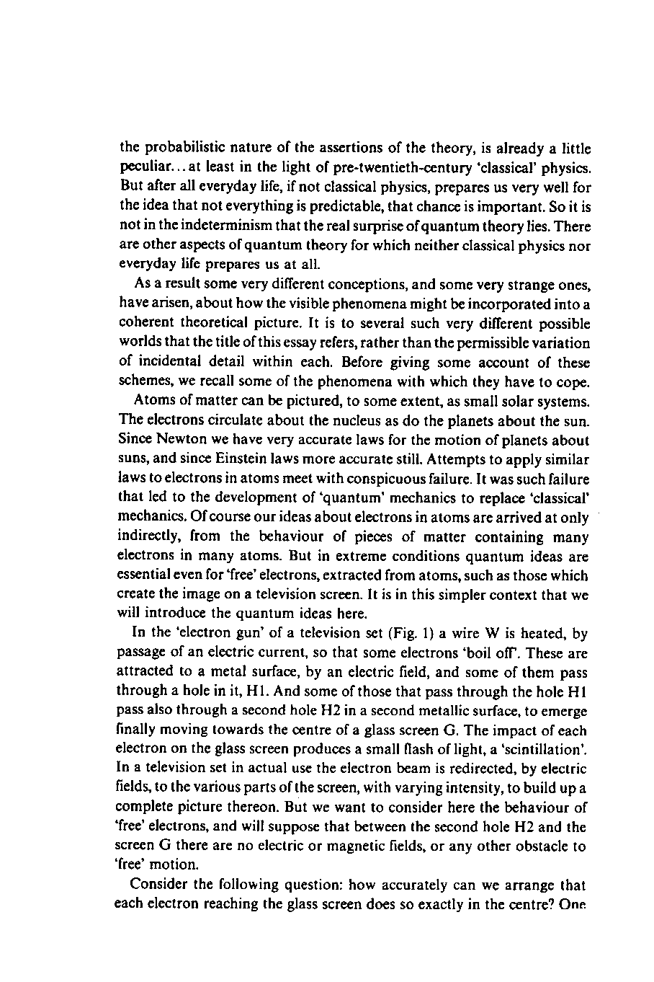
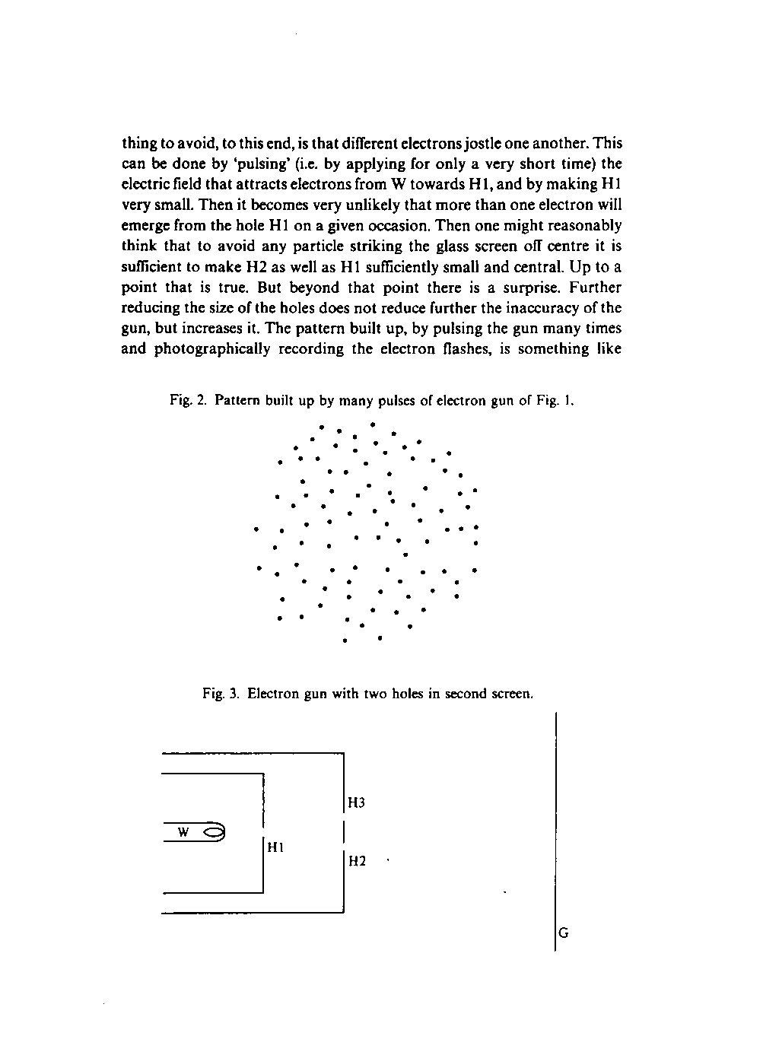
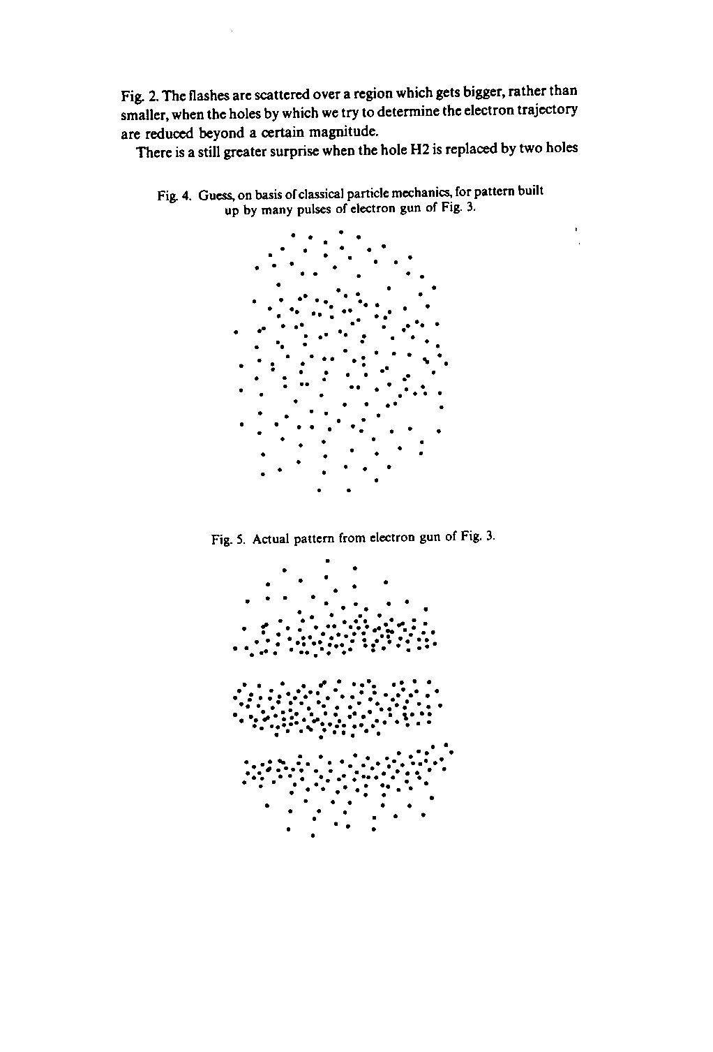
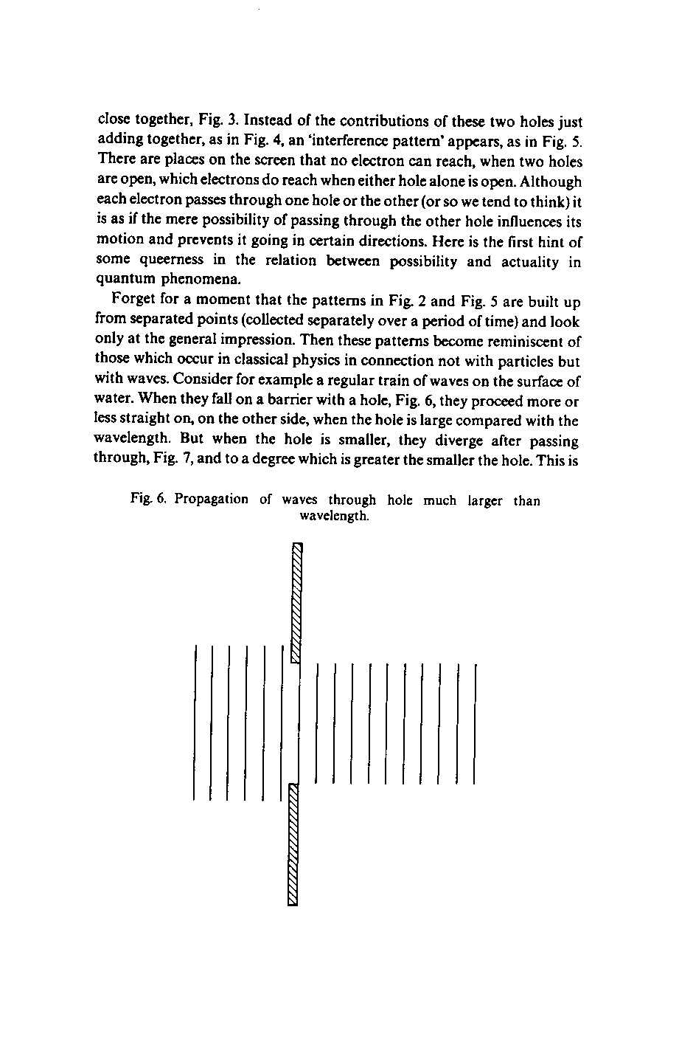
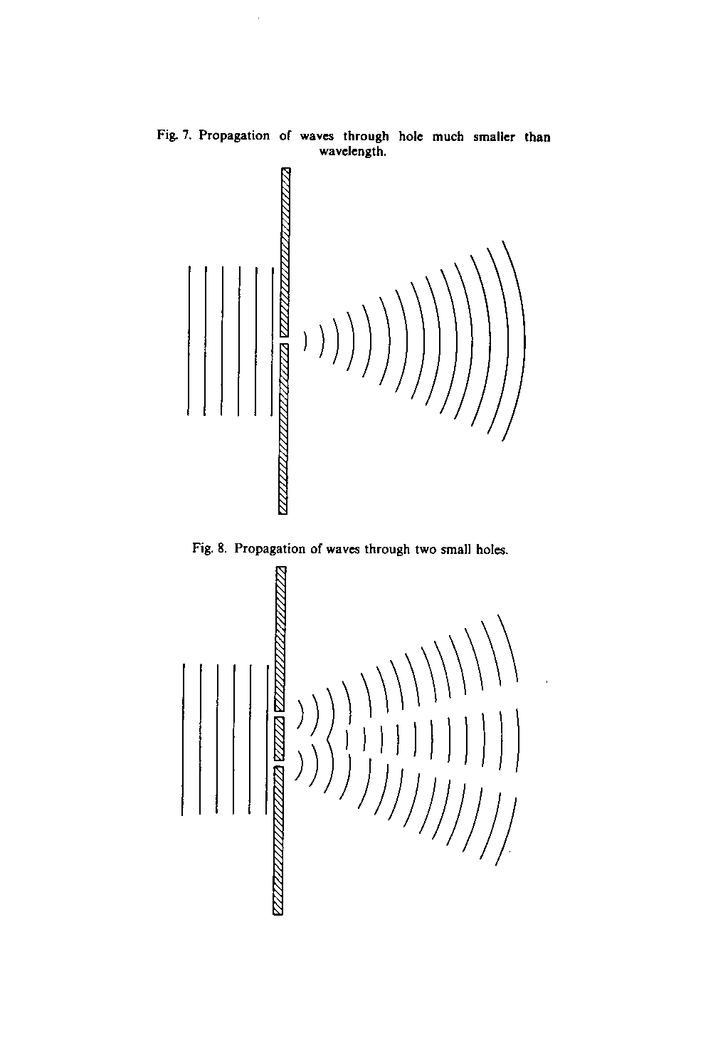
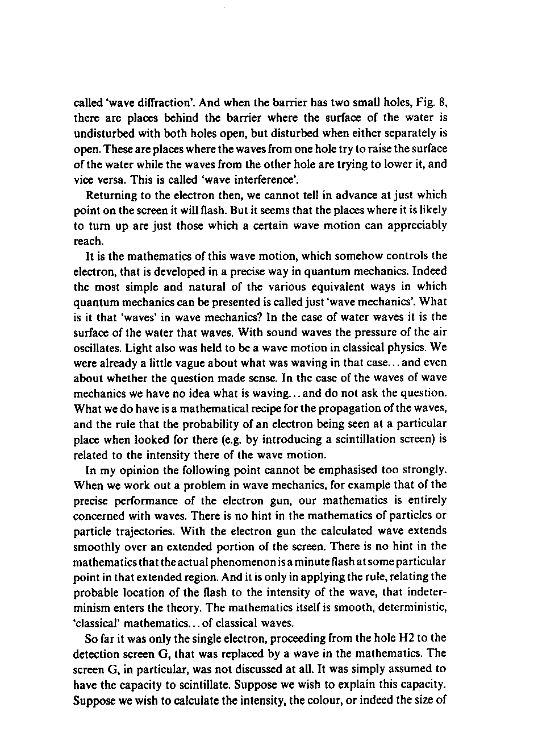
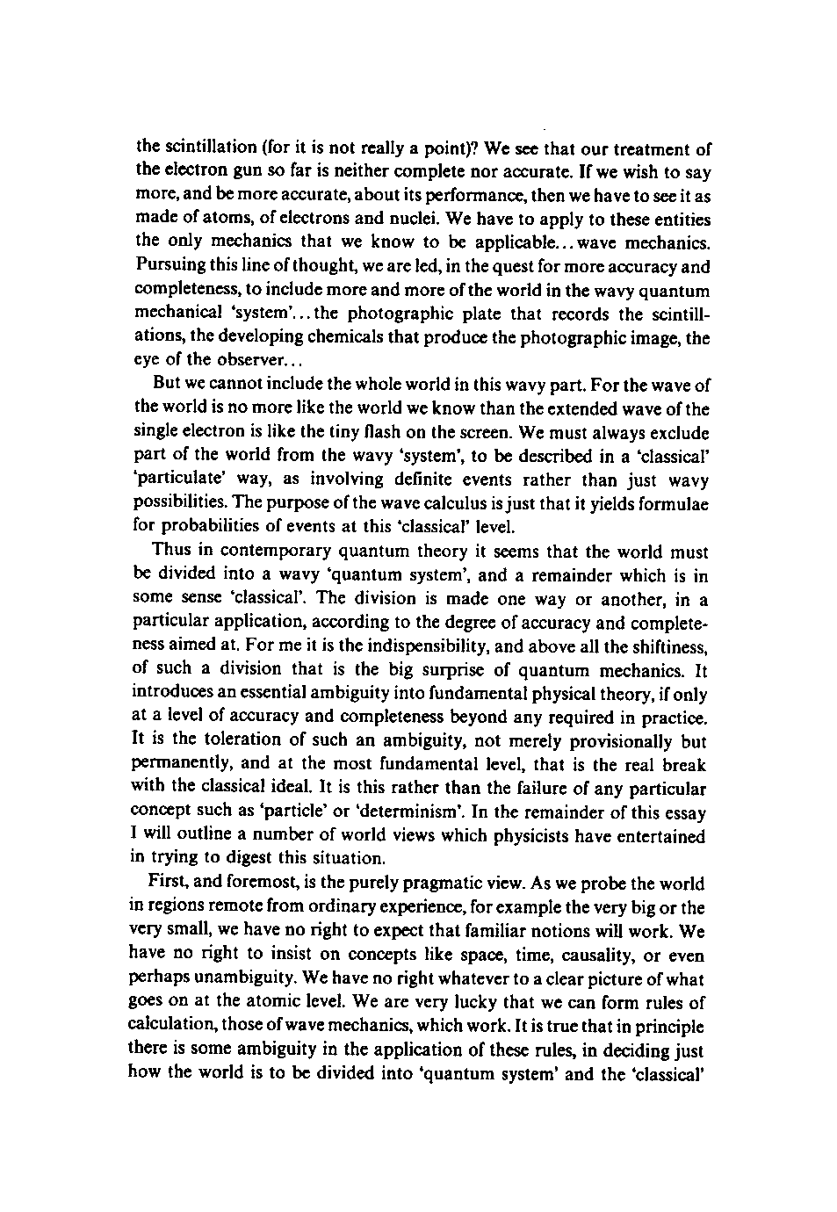
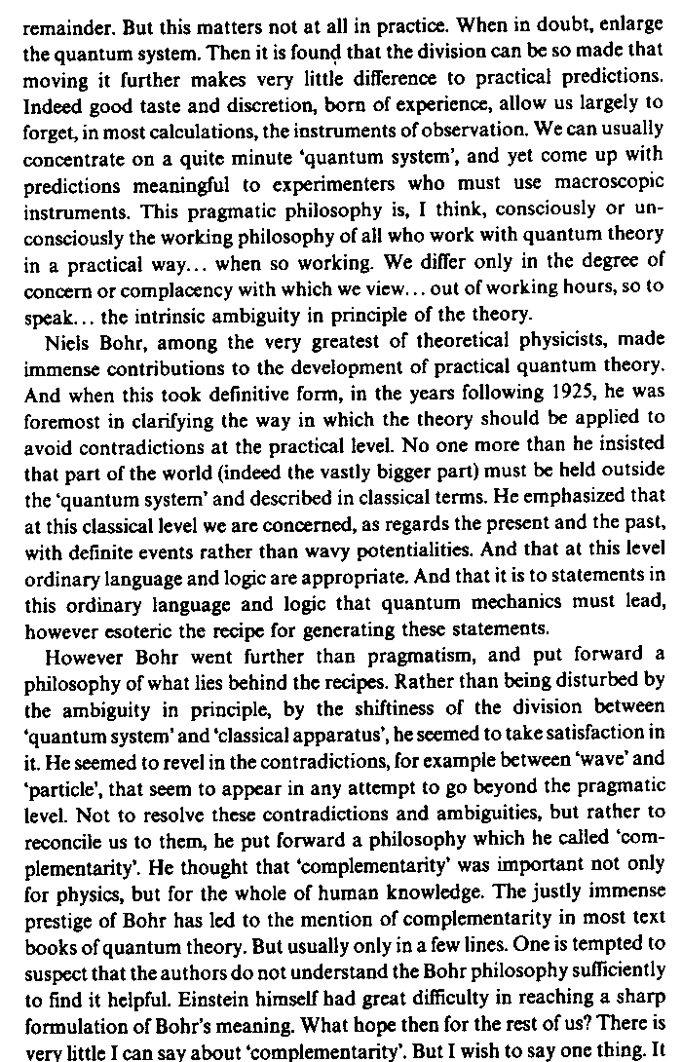
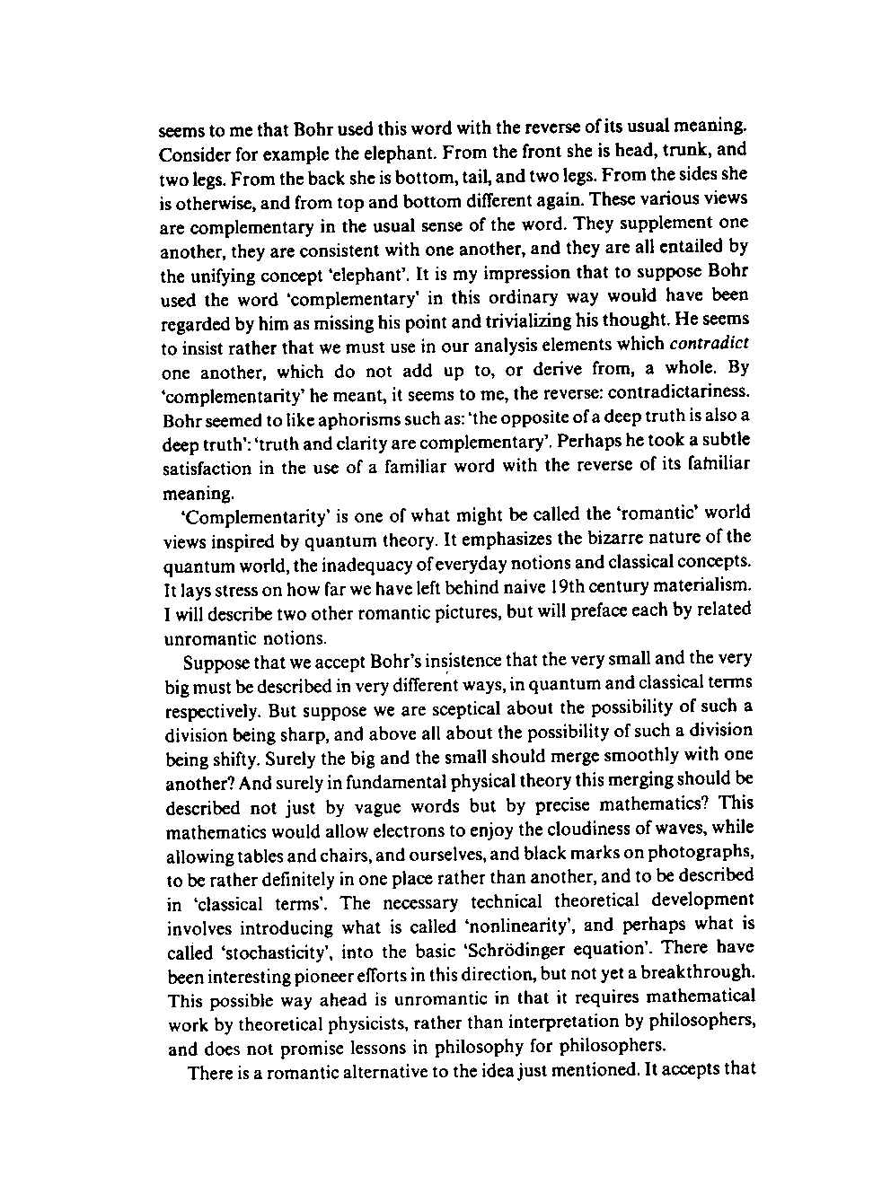
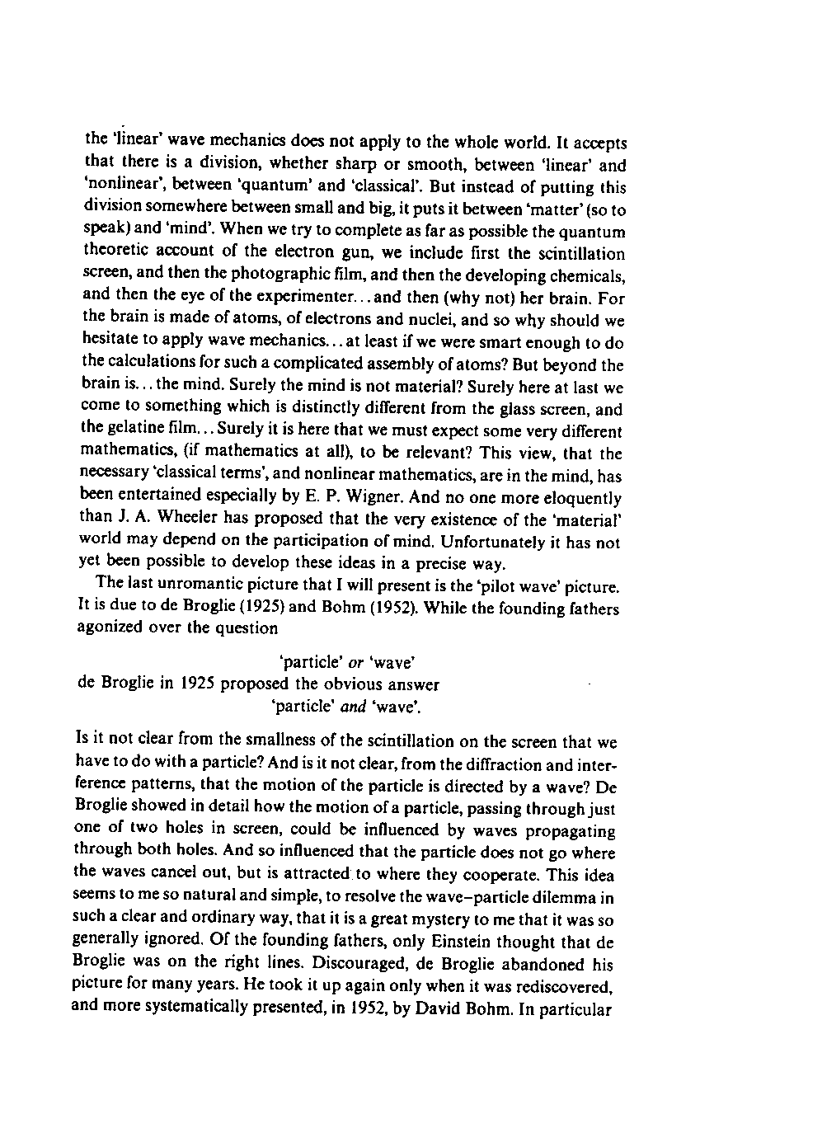
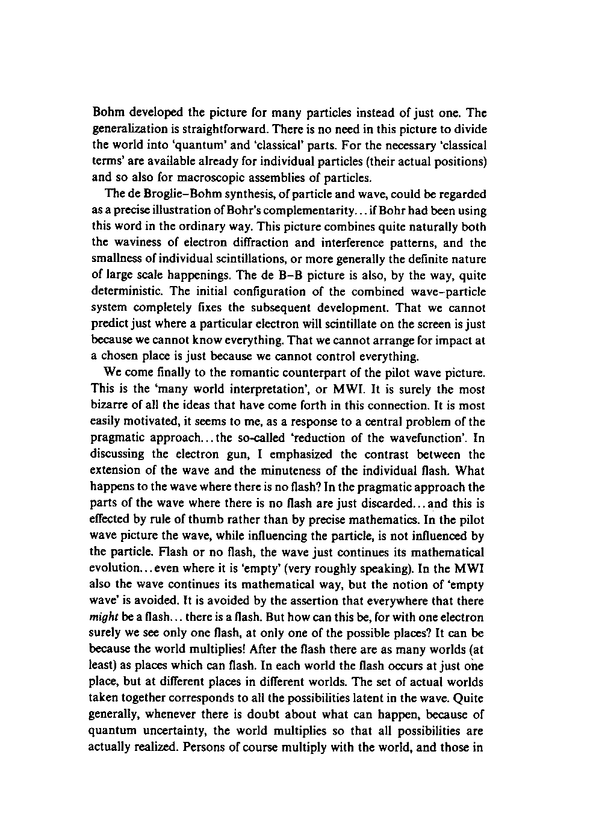
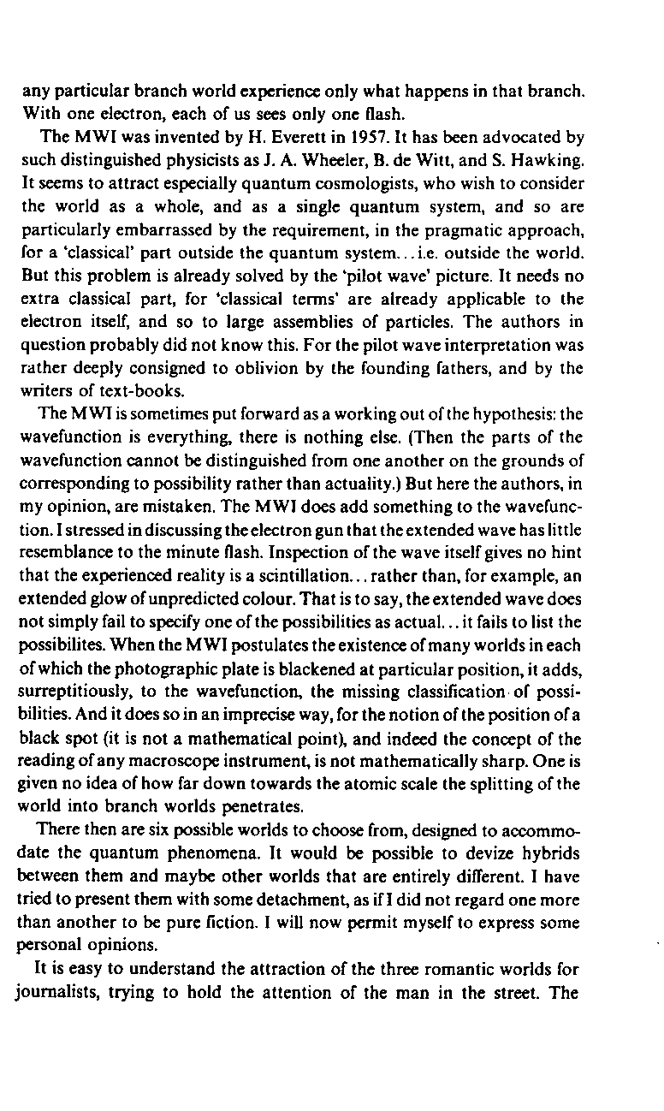
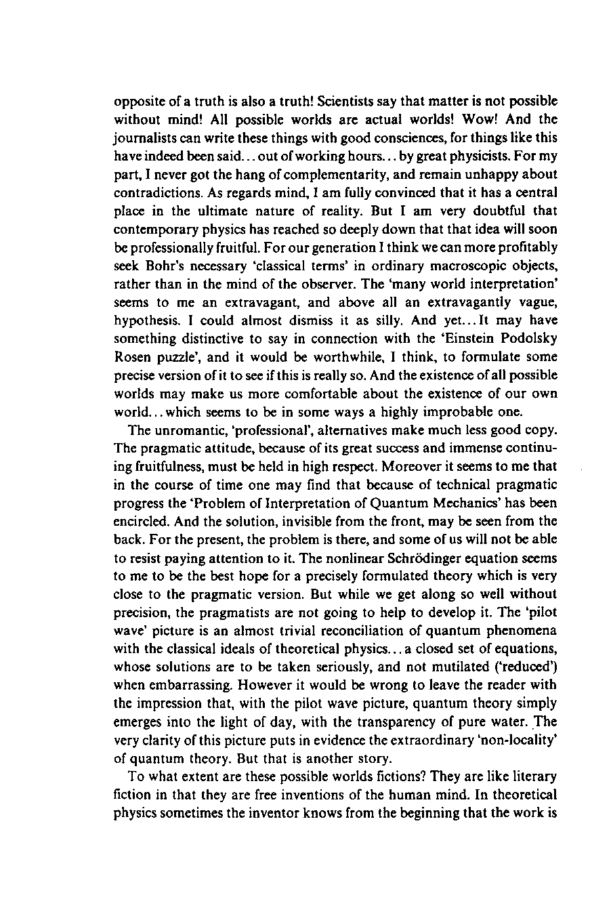
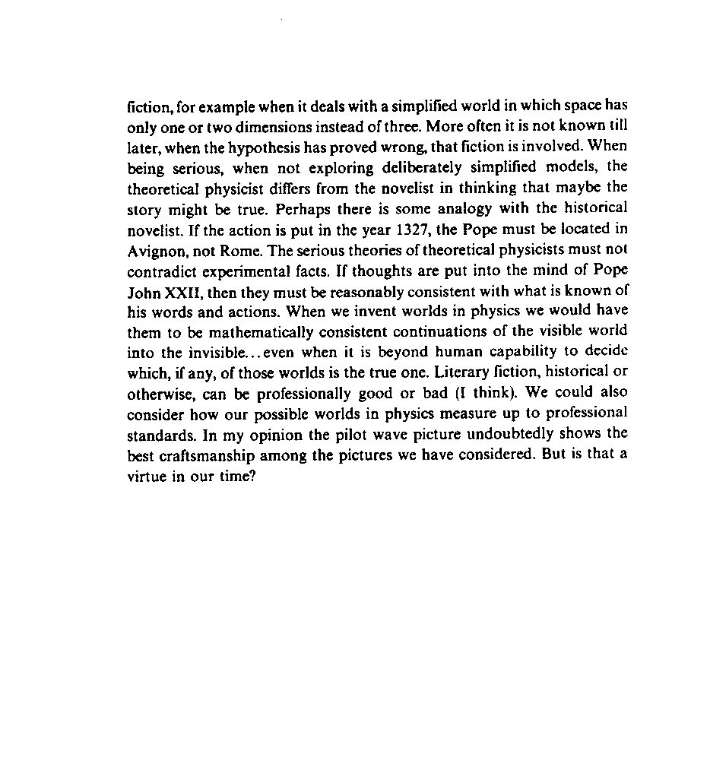

BOHM INTERPRETATION*

The Bohm interpretation of quantum mechanics, sometimes called Bohmian mechanics, the ontological interpretation, or the casual interpretation, is an interpretation postulated by David Bohm in 1952 as an extension of Louis de Broglie’s pilot-wave theory of 1927. Consequently it is sometimes called the de Broglie-Bohm theory. Bohm interpretation is an example of a hidden variables theory. It is hoped that the hidden variables would provide a local deterministic objective description that would resolve or eliminate many of the paradoxes of quantum mechanics, such as Schrödinger cat, the measurement problem, the collapse of the wave function, and similar concerns. However, Bell inequality complicates this hope, as it demonstrates that there is no local hidden variable theory that is compatible with quantum mechanics. Thus, one is left with choosing between the lesser of two evils: discarding locality, or discarding realism. The Bohmian interpretation opts for realism, albeit non-local. It is unclear, however, how it can be compatible with quantum field theory, which is essentially local.

Background
The Bohm interpretation can be thought of as taking its cue from what one sees in the laboratory, say, in a two-slit experiment with electrons. We can see localized flashes whenever an electron is detected at some place on the screen. The overall pattern made by many such flashes is governed by a pattern closely matched by simple wave dynamics. Bohm and de Broglie posited that in the world of quantum phenomena, every kind of particle is accompanied by a wave which guides the motion of the particle, hence the term pilot wave. Mathematically, the pilot wave is described by the wave function of conventional quantum mechanics, but with an added piloting influence on the motion of the particles.
We can formulate the pilot waves influence using a wave function-derived potential called the quantum potential. which acts upon the particles in a manner analogous to the interaction of p[articles and fields in classical physics. The pilot wave governs the motion of the particle and evolves according to the Schrödinger equation. Unlike the Everett many-worlds interpretation. the Bohm interpretation does not assume that the universe splits when a measurement occurs. and unlike the Copenhagen interpretation it is both objective and deterministic. It says the state of the universe evolves smoothly through time, with no collapsing of wave functions. Thus, Bohm called the hidden variable or pilot wave the quantum potential force or dark force, in comparison to dark matter and dark energy.
Two-slit experiment
Thus, in this theory all fundamental entities, such as electrons, are point-like particles that occupy precisely defined regions of space at all times. When one performs a double-slit experiment), one is concerned with noting the positions on a screen at which electrons arrive individually, one at a time. Over time, the positions at which the electrons arc detected build up a pattern characteristic of wave interference. The usual Copenhagen interpretation is puzzling in that a single entity, the electron, is said to exhibit characteristics of both particle and wave. The Bohm interpretation accounts for the same phenomena by saying that both a particle and a wave do exist. The particle aspect is present because each electron traverses one slit or another, but never both. The wave aspect is present because the electron pilot wave traverses both slits.
Thus, the Bohm interpretation resolves the puzzle quite simply and naturally. The electron motion is guided — both in its choice of slits and its subsequent trajectory towards the screen — by the wave. The characteristic wave-interference pattern seen in the detection of the electrons arises by considering that the guiding wave exhibits interference in the familiar way one learns in the elementary physics of waves.
One might also note that what is measured in such an experiment — the position on the screen at which each electron arrives — is itself none other than the „hidden variable” the Bohm interpretation adds to the description, as we show in the formulation below. It might seem that the term „hidden variables” is an inappropriate name for the positions of particles, the quantity that is apparently most conspicuously manifested in the experiment. However, the particle position has no influence on the guiding wave and hence is unobservable or „hidden” in some sense (see criticisms).

Nonlocality

Now we must address the question of nonlocality. Within Bohm interpretation, it can occur that events happening at one location in space instantaneously influence other events which might be at large distances: thus we say that the theory fails to obey locality, i.e., it is non-local. The response many physicists have to Bohm theory is often related to how they regard this concept.
The question of nonlocality hinges upon the attitude one takes towards the Einstein-Podolsky-Rosen paradox and Bell’s theorem According to one camp, it has been shown that quantum mechanics itself is nonlocal and that this cannot be avoided by appealing to any alternative interpretation. The same Bell responsible for Bell theorem was a member of this group [ „It is known that with Bohm’s example of EPR correlations, involving particles with spin, there is an irreducible nonlocality.” If this is indeed the case, then the nonlocality of the Bohm interpretation can hardly be regarded as a strike against it.
Others see the consequences of EPR and Bell’s theorem in a different way. They regard the correct conclusion to be related not so much to quantum theory itself, but only to deterministic interpretations of the same (i.e., to hidden-variable theories such as Bohm’s interpretation). According to the people who think this way, what has been shown is that all deterministic theories must be nonlocal. For example, N. Bohr was a member of this group. This group would claim that retaining orthodox quantum mechanics — with its probabilistic character — permits one to retain locality, or at least to avoid the EPR type of nonlocality, at the expense of haying no way to picture particles as objective elements of reality that occupy definite regions of space at all times. Armed with such a viewpoint, these physicists tend to be less receptive to Bohm interpretation.

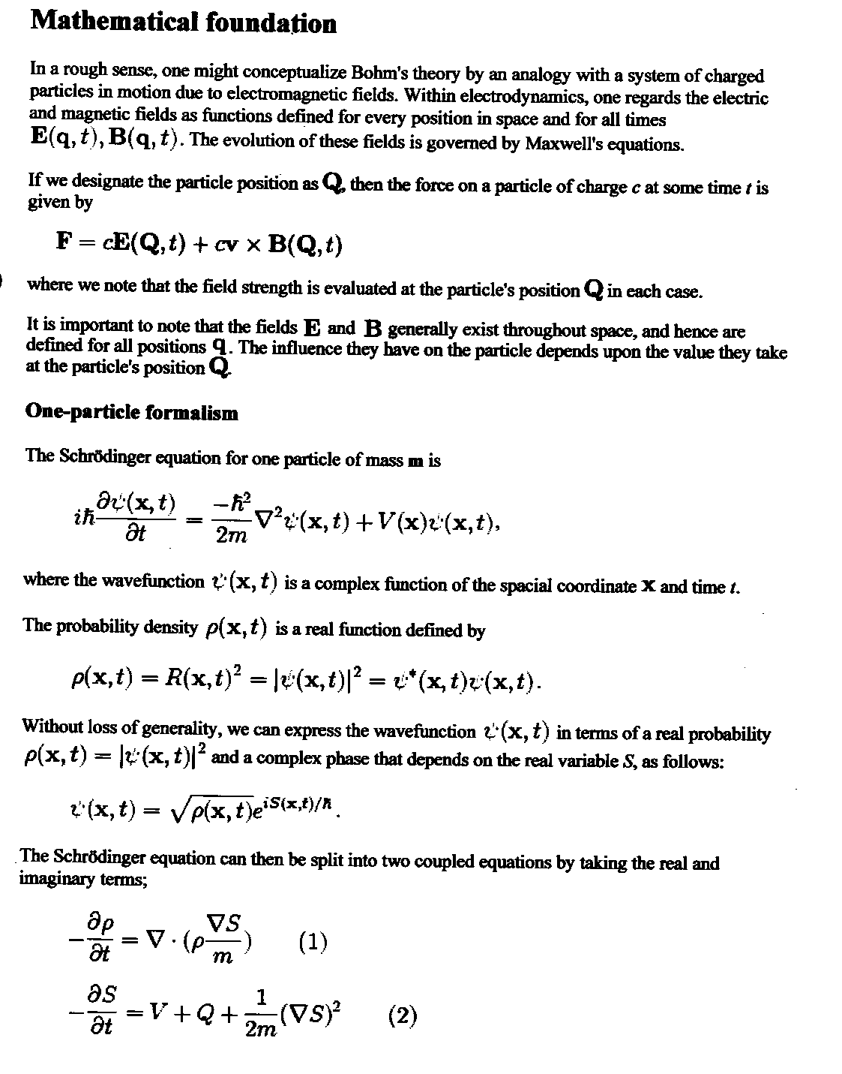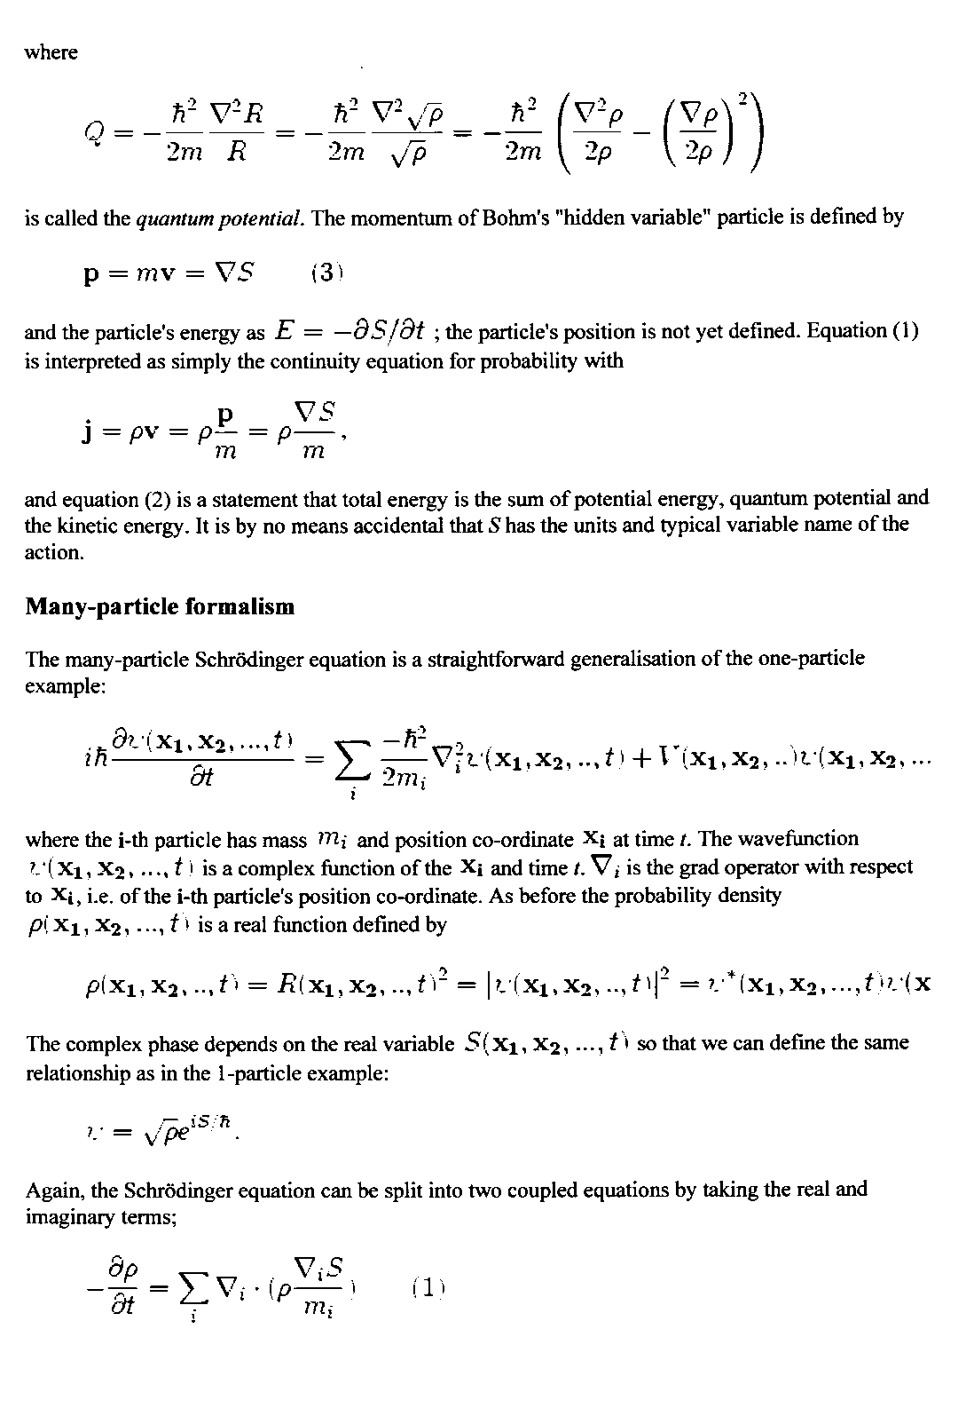
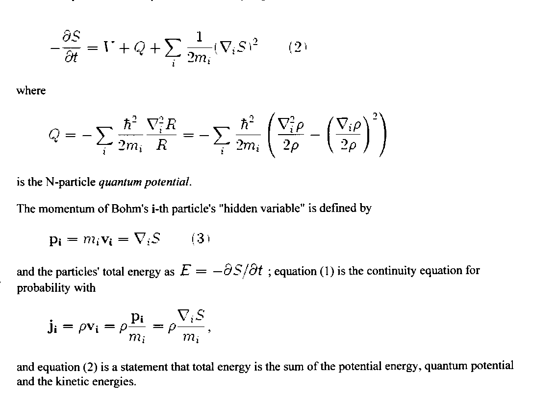

For supporters, Bohm interpretation provides a better formulation of quantum mechanics because it is defined more precisely than the Copenhagen interpretation, which is based on theorems that are not expressed in precise mathematical terms but in natural words, like „when measuring.” Indeed, the Bohm interpretation subsumes the quantum concepts of measurement, complementarity, decoherence, and entanglement into mathematically precise guidance conditions on position variables. Although it implies the existence of the EPR type o nonlocality, it avoids the need for positing other types of nonlocality, such as wave collapse or splitting universes.
The minimum benefit of Bohm interpretation, independent of the debate about whether it is the preferable formulation, is a disproof of the claim that quantum mechanics implies that particles can not exist before being measured.
Because it is based on familiar concepts of realism, the Bohm interpretation gives simple, intuitive, non-mystical, and natural answers to what in the standard theory are often perplexing philosophical questions. For example, every particle exists all the time and has a unique position, eyen when it is not being measured. In the double-slit experiment for electrons, each electron travels through only one slit, but the e1ectron pilot wave causes the interference pattern. Not only the wave, but the trajectory of each electron can be calculated when one knows the position where the electron hit the screen. This basis in realism strengthens the Bohm interpretation ties to the concepts of classical physics.
Criticisms
The main points of critics, together with the responses of Bohm-interpretation advocates, are summarized in the following points:
• Bohm interpretation does not reproduce quantum field theory, which is the modern theory of quantum mechanics, which has been verified experimentally remarkably well. Since locality is essential to quantum field theory, it is unclear that it is possible to reproduce it via Bohm interpretation.
• The main weakness of Bohm theory is that it looks contrived — and gives the same measurable predictions which are in all details identical to conventional quantum mechanics, It is not really a scientific theory.?
Response: Bohm deliberately designed his theory to give the same predictions as the conventional approach. His original aim was not to make a serious counterproposal but simply to demonstrate that hidden-variables theories are indeed possible, contrary to the earlier belief (due to von Neuman) that they are not possible. To accomplish this aim it was necessary that the predictions of the two theories be the same. However, Bohm’s hope was that this demonstration could lead to new insights and experiments. Bohm theory can be extended in ways that cannot even be contemplated in the conventional theory, and these extensions may lead to new measurable predictions.
Furthermore, in clarifying theoretical issues such as nonlocality the theory already has been highly successful. The theory inspired John Stewart Bell to prove his now-famous theorem, which in turn led to the Bell test experiments. This would be a rather amazing accomplishment for a theory that is „not really scientific.”
The wave function must „disappear” or „collapse” after a measurement, and this process seems highly unnatural in the Bohmian models.
Response: Collapse is a main feature of von Neumann theory of quantum measurement. In the Bohm interpretation, a wave does not collapse. Instead, a measurement produces what Bohm called „empty channels” consisting of portions of the wave that no longer affect the particle. This explains why physical systems behave as if parts of the wave function had disappeared, despite the fact that there is no true disappearance or collapse. (The process whereby a quantum system interacts with its environment to give the appearance of wave function collapse is called decoherence.)
• The theory artificially picks privileged observables: while orthodox quantum mechanics admits many observables on the Hilbert space that are treated almost equivalently (much like the bases composed of their eigenvectors), Bohm interpretation requires one to pick a set of „privileged” observables that are treated classically — namely the position. There is no experimental reason to think that some observables are fundamentally different from others.
Response: Every physical theory can be rewritten based on different fundamental variables without being different empirically. The Hamilton-Jacobi equation formulation of the classical mechanics is an example. Positions may be considered as a natural choice for the selection because positions are most directly measurable.
• The Bohmian models are truly nonlocal: this nonlocality violates Lorentz invariance; contradictions with special relativity are therefore expected; they make it highly nontrivial to reconcile the Bohmian models with up-to-date models of particle physics, such as quantum field theory or string theory, and with some very accurate experimental tests of special relativity, without some additional explanation. On the other hand, other interpretations of quantum mechanics, such as consistent histories or the many-worlds interpretation, allow us to explain the experimental tests of quantum entanglement without any nonlocality whatsoever.
Response: Nonlocality and Lorentz invariance are not in contradiction. An example of a nonlocal Lorenz-invariant theory is the Feynman-Wheeler theory of electromagnetism.
Furthermore, it is questionable whether other interpretations of quantum theory are in fact local or are simply less explicit about nonlocality. See for example the EPR type of nonlocality. And recent tests of Bell Theorem add weight to the belief that all quantum theories must abandon either the principle of locality or counterfactual definiteness (the ability to speak meaningfully about the definiteness of the results of measurements, eyen if they were not performed).
That said, it is true that finding a Lorentz-invariant expression of the Bohm interpretation (or any similar nonlocal hidden-variable theory) has proved difficult, and it remains an open question for physicists today whether such a theory is possible and how it would be achieved.
• The Bohmian interpretation has subtle problems with incorporating spin and other concepts of quantum physics: the eigenvalues of the spin arc discrete, and therefore contradict rotational invariance unless the probabilistic interpretation is accepted.
Response: This criticism is based on the false assumption that the particle position variables in Bohm equations must carry spin. There are natural variants of the Bohm interpretation in which such problems do not appear. In these, spin is a property of the wave only; the particle variables have no spin in the mathematical formulation.
The Bohmian interpretation also seems incompatible with modern insights about decoherence that allow one to calculate the „boundary” between the „quantum microworld” and the „classical macroworld”; according to decoherence, the observables that exhibit classical behaviour are determined dynamically, not by an assumption.
Response: When the Bohm interpretation is treated together with the von Neumann theory of quantum measurement, no incompatibility with the insights about decoherence remains. On the contrary, the Bohm interpretation may be viewed as a completion of the decoherence theory. It provides an answer to the question that decoherence by itself cannot answer: What causes the system to pick up a single definite value of the measured observable? And the fact that the theory does not postulate the existence of any boundary between two „worlds” can be viewed as one of its major advantages.
Another possible route to new predictions is opened up by current developments in quantum chaos. In this theory, there exist quantum wave functions that are fractal and thus differentiable nowhere. While such wave functions can be solutions of the Schrödinger equation taken in its entirety, they would not be solutions of Bohm coupled equations for the polar decomposition of into p and S, given above. The breakdown occurs when expressions involving p or S become infinite (due to the non differentiability), even though the average energy of the system stays finite, and the time-evolution operator stays unitary. As of 2005, it does not appear that experimental tests of this nature have been performed.
• The Bohm interpretation involves reverse-engineering of quantum potentials and trajectories from standard QM. Diagrams in Bohm book are constructed by forming contours on standard QM interference patterns and arc not calculated from his „mathematical” formulation.
Response: The Bohm interpretation takes the Schrödinger equation even more seriously than does the conventional interpretation. In the Bohm interpretation, the quantum potential is a quantity derived from the Schrodinger equation not a fundamental quantity. Thus, the interference patterns in the Bohm interpretation are identical to those in the conventional interpretation.

CHAPTER 4

QUO VADIS QUANTUM MECHANICS?

The present status of the Schrodinger wave mechanics was dominated by the interpretations of the Bell inequality. Bell inequality is rooted in two assumptions. The first is what we call objective reality – the reality of the external world, independent of our observations; the second is locality – no faster than light signalling. Aspect’s experiment appears to indicate that one these two has to go!
J. S. Bell sees the solution of this dilemma in the reformulation of SWT, as it was before Einstein, when people like Lorentz and Poincaré thought that there was an ether - a preferred frame of reference – but that our measuring instruments were distorted by motion in such a way that we could not detected motion through the ether. Now in that way we can imagine that there is a preferred frame of reference, and in this preferred frame of reference things do go faster than light. Behind the apparent Lorentz invariance of the phenomena, there is a deeper level which is not Lorentz invariant.
The reason J. S. Bell wanted to go back to the idea of an ether is because in the EPR experiment there is the suggestion that behind the scenes something is going faster than light. Now, if all Lorentz frames are equivalent that also means that things can go back in time.
This approach introduces great problems paradoxes of causality and so on. And so it’s precisely to avoid these that J. S. Bell wants to say that there is a real causal sequence which is defined in the ether. Now the mystery is, as with Lorentz and Poincaré that this ether does not show up at the observational level. It is as if there is some kind of conspiracy that something is going on behind of scenes which is not allowed to appear on the scenes.
In conclusion J. S. Bell prefers to retain the notion of objective reality and throw away one of the tends of relativity: that signals cannot travel faster than the speed of light.
It seems that it is to be able to take a realistic view of the world to talk about the world as it is really there, even when it is not being observed. And I believe that most physicists take this point of view when they are being pushed into a corner.. by Bohr.
As was stated by J. S. Bell: “… quantum theory is only a temporary expedient”.
It does not really explain things; in fact the founding fathers of quantum mechanics rather pried themselves on giving up the idea of explanation. They were proud that they dealt only with phenomena: they refused to look behind the phenomena.
As stated by J. S. Bell the discussions about what quantum mechanics means will lead to still more and more tricky experiments which will eventually find some soft spot, some point where quantum mechanics is actually wrong.

APPEDIX A

Wave Nature of Biomolecules and Fluorofullerenes

Lucia Hackermu¨ller, Stefan Uttenthaler, Klaus Hornberger, Elisabeth Reiger, Bjo¨rn Brezger,*
Anton Zeilinger, and Markus Arndt
Institut fu¨ r Experimentalphysik, Universita¨t Wien, Boltzmanngasse 5, A-1090 Wien, Austria†

We demonstrate quantum interference for tetraphenylporphyrin, the first biomolecule exhibiting wave nature, and for the fluorofullerene C60F48 using a near-field Talbot-Lau interferometer. For the porphyrins, which are distinguished by their low symmetry and their abundant occurrence in organic systems, we find the theoretically expected maximal interference contrast and its expected dependence on the de Broglie wavelength. For C60F48, the observed fringe visibility is below the expected value, but the high contrast still provides good evidence for the quantum character of the observed fringe pattern.
The fluorofullerenes therefore set the new mark in complexity and mass (1632 amu) for de Broglie wave experiments, exceeding the previous mass record by a factor of 2.
The wave-particle duality of massive objects is one of the cornerstones of quantum physics. Nonetheless, this quantum property is never observed in our everyday world. The current experiments are aiming at exploring the limits to which one can still observe the quantum wave nature of massive objects and to understand the role of the internal molecular structure and symmetry.
Coherent molecule optics was already initiated as early as 1930 when Estermann and Stern confirmed de Broglie’s wave hypothesis [1] in a diffraction experiment with He atoms and H2 molecules [2]. In contrast to the rapidly evolving field of electron and neutron optics, atom optics became only feasible about 20 years ago and has led from experiments with thermal atoms to coherent ensembles of ultracold atoms forming Bose- Einstein condensates. Molecule interferometry was only taken up again in 1994 with the first observation of Ramsey-Borde´ interferences for I2 [3] and with the proof of the existence of the weakly bound He2 in a far-field diffraction experiment [4]. Experiments with alkali dimers in the far-field [5] and in near-field [6] interferometers followed. Recent interest in molecule optics has been stimulated by the quest for demonstrations of fundamental quantum mechanical effects with mesoscopic objects [7–9].
In the present Letter, we report the first demonstration of the wave nature of both t tetraphenylporphyrin (TPP) and of fluorinated fullerenes using near-field interference.The porphyrin structure is at the heart of many complex biomolecules, serving as a color center, for instance, in chlorophyll and in hemoglobin. The fluorofullerene C60F48 is the most massive (1632 amu) and most complex (composed of 108 atoms) molecule for which the de Broglie wave nature has been shown thus far (see Fig. 1).
In order to demonstrate the wave property of a massive object with a short de Broglie wavelength, it is advisable to use a near-field diffraction scheme. In particular, a Talbot-Lau interferometer (TLI, for details see [11–14]) is compact and rugged, has favorable scaling properties, permits one to work with acceptable grating constants even for large molecules, and allows one to work with an initially uncollimated and spatially incoherent beam. The basic structure of our interferometer has been described elsewhere [13]. The experiment is set up in a vacuum chamber at a base pressure of 2 _ 10_8 mbar, which is sufficient to avoid molecule loss or decoherence by residual gas scattering in the interferometer [15]. The molecular beam is created by sublimation in an oven. TPP was heated to 690Kcorresponding to a vapor pressure of 46 Pa [16]. C60F48 was sublimated at 560 K with a vapor pressure of 2.3 Pa [17].
The initial thermal velocity distribution is rather broad (full width at half maximum _50%), both for TPP and for C60F48. We therefore apply a gravitational v-selection scheme: Three horizontal slits restrict the beam to a welldefined free-flight parabola. The first slit is given by the orifice of the oven (200 _m high). The central height limiter is situated at 138 cm (for TPP) and 126 cm, respectively (for C60F48) behind the oven. Its opening is set to 150 _m. The third horizontal slit (100 _m) is positioned 10 cm from the molecule detector. For porphyrin we achieve a velocity resolution between Δv/v_{m} = 30% (full width at half maximum) at a mean velocity of v_{m}=160 m/s and _v=v_{m}= 40% at v_{m}= 235 m/s. For C60F48, the value is _v=v_{m} = 20% at v_{m}= 105 m/s. The velocities can be varied by changing the vertical position of the source and they are measured using a time-of-flight method. The interferometer itself consists of three identical gold gratings with a grating period of g= 991.3nm+- 0.3 nm, a nominal open fraction of f= 0:48+-- 0:02, and a thickness of b _ 500 nm (Heidenhain, Traunreut).
The first grating prepares the transverse coherence of the molecular beam. The second grating is responsible for the diffraction and interference. The third grating is used to mask the molecular interference pattern and is therefore already part of the detection scheme, providing high spatial resolution. The distance L between the first and the second grating and that between the second and the third grating are equalized to within 100 _m and are of the order of the Talbot length LT _ g2=_dB for the most probable wavelength of the thermal molecular beam. They are set to 0.22 m for the porphyrins and to 0.38 m for C60F48. The alignment and distance of the gratings have been carefully set in a calibration experiment using C70. To record the molecular interferogram, the third grating is scanned across the molecule beam using a piezoelectric translation stage. The number of transmitted molecules as a function of the third grating position is then the measure for the spatial molecular distribution.
The quantum wave nature of the resulting molecule pattern is reflected in the strong wavelength dependence of the fringe visibility.
A previous Talbot-Lau setup had proven successful before [13] but the detector was limited to the special case of fullerenes since it employed a thermal laser ionization scheme which cannot be applied to those molecules which have an ionization energy exceeding the binding energy. In contrast to these earlier experiments, all results presented here were obtained using electronimpact ionization. Although this ionization mechanism has a much lower efficiency than the optical scheme, it is more universal and can be applied to virtually any molecule up to a mass of about 2000 amu. The universality of electron-impact ionization is important but it also implies the necessity of a mass selection stage to prevent the residual gases in the vacuum chamber from contributing to the signal. In our experiment, this selection is done using a quadrupole mass spectrometer (ABB Extrel, 2000 amu).
The first set of experiments reported here was done with meso-tetraphenylporphyrin (TPP), C44H30N4, with a purity of 98% as purchased from Sigma-Aldrich (Fig. 1, left). It has a diameter of _20 ~A, which is about twice the size of C60. The flat geometry of TPP (aspect ratio _7) is rather different from the highly symmetric structure of the fullerenes which were used in previous studies. One might imagine two possible effects of the asymmetric structure which can influence the interference contrast. First, there could be an orientation-dependent coupling between the molecules and the gratings. Molecules with an anisotropic polarizability will experience an angle dependent phase shift due to the van der Waals interaction with the grating walls. This may change the interference contrast considerably (see, e.g., [13]). However, at several hundred Kelvins the molecules rotate at a frequency of about 10¹³ s^{_1} which should lead to an effective averaging of orientation-dependent effects. Second, the structure might give rise to ‘‘internal’’ decoherence. This could be the case if one molecular axis acted as the hand of a pointer showing finally in different directions depending on which path the molecule took through the interferometer. If stray field gradients vary on the scale of the molecular path separation, as for instance caused by patch fields in the grating slits, they might encode which-path information in the internal (e.g., rotational) state. The electric or magnetic moments required for the coupling to the local fields usually grow with increasing size and decreasing symmetry of the molecules.
To confirm the absence of any effect of the molecular geometry on the de Broglie interference, it is important to reach experimentally the fringe contrast which is predicted from the description of the center of mass motion and the scalar molecular properties alone.
Figure 2 now shows the TPP interference fringes obtained for a mean velocity of vm _ 160 m=s as the third grating is shifted in steps of 100 nm across the molecular density profile. At each step the intensity was recorded over a period of 2 s. This figure is the sum of 20 scans. For our particular grating design, quantum mechanics predicts a nearly sinusoidal molecule intensity as a function of the grating displacement [14]. We therefore fit a sine function on top of a mean count rate and a fixed, measured background to the data. The fringe visibility is then determined as the ratio of the amplitude to the mean count rate of this fit. The observed contrast is very close to the theoretically predicted value of 34%, and differs significantly from the classically expected value of 14%
(see discussion below).
In order to further support the interpretation of our data as being due to the molecular wave nature, we show in Fig. 3 (full dots) the wavelength (i.e., velocity) dependence of the fringe contrast. Four different velocity distributions were selected from the initial thermal distribution.
For each of them, the contrast was determined by averaging ten scans as described above. The quantum mechanical calculation (continuous line)—which includes the molecule/wall interaction [14]—fits the experimental data rather well within the experimental errors. The error bars in Fig. 3 give the measured statistical standard deviation within a series of ten scans [18].
However, one might argue that a periodic density pattern behind grating three could in principle also result from classical dynamics. Simple shadow images of two gratings are commonly known as moire´ fringes. They also depend slightly on the velocity of the passing object if we take into account the molecule-wall interaction. The classically predicted contrast differs significantly from the measured visibility both in magnitude and in velocity dependence (Fig. 3, dashed line).
Having proven the perfect contrast for a molecule of low symmetry, it is encouraging to investigate a more complex object. C60F48 is among the heaviest objects that can be thermally vaporized and detected in our mass spectrometer. It was purchased from Sidorov (State University Moscow) and had a specified purity of 95%. The fluorofullerenes are present in several isomers with D3 and S6 symmetry. Typical count rates were only about 100 counts/s (cps) including a spectrometer background of 70 cps with a noise of 30%. In addition, the background increased up to 130 cps towards the last recording. The much reduced signal-to-noise ratio (with respect to TPP), the extended measuring time, and the correspondingly larger drifts require a very careful data evaluation.
The total intensity is recorded as a function of the position of the third grating, which was shifted in steps of 40 nm over a distance of 3 _m. In total, a series of 68 scans were recorded over 5 h. Every second scan was a background scan, where the source was blocked. Repeated background measurements were necessary since the dark count rate was changing over time. The single scans are shifted with respect to each other due to thermal drifts of the gratings of up to a few 100 nm between subsequent scans. Therefore a simple average of all data is not reasonable.
The best fitting sine curve of each single interference pattern was evaluated using a Fourier transformation and each pattern was shifted to a common origin according to its phase. Averaging over all recorded scans, regardless of their individual quality, yields an interference contrast of 13%, which would still be explicable in classical terms.
However, this includes scans with high background noise which show no interference at all and which lower the resulting contrast considerably. In order to eliminate the noisy graphs without introducing an additional bias by the selection, all scans were sorted according to their _2 value obtained from the Fourier transformation. The _2 value is here a measure for the distribution of spatial frequencies in the molecular density pattern. A large _2 occurs if there is more than a single relevant spatial frequency; i.e., it is increasing with increasing deviation from the expected sine wave shape of the interferogram.
It is important to note that this procedure selects recordings with a clear period, but it explicitly avoids any restrictions on the particular value of this period. Taking only the fraction R of all scans with the lowest _2 value, we find an increasing interference contrast for decreasing R. A maximal contrast of about 27% is observed for R _ 0:1; . . . ; 0:5, while single scans are too noisy to reach this
value. We estimate the error of the visibility for the selected set to _3%. It is also significant and important that the only high contrast variation in the molecular density pattern is found at the expected spatial period of _1 um. Figure 4 shows three periods of the interference fringes of C60F48 selected with R _ 0:4.
It is important to note that this procedure selects recordings with a clear period but it explicitly avoids any restrictions on the particular value of this period. Taking only those 40% of all scans with the lowest _2 value, we find an interference contrast of 27%. The statistical error of the selected set amounts to _3%. It is also significant and important that the only observed high contrast variation in the molecular density pattern is found at the expected spatial period of _1um. Figure 4 shows three periods of the thus selected interference fringes of C60F48.
This high visibility is good evidence for the quantum wave character of the interference fringes since it lies significantly above the classically expected contrast of 12%. However, the expected quantum mechanical value of 36 _ 3% is still higher than the experimental contrast. Some information on the origin of this discrepancy is provided by the fact that pure C70, which can be detected using cw-laser ionization and which does not suffer from any significant detector noise, exhibits perfect interference in the same Talbot-Lau setup at a velocity of 200 m=s but it shows a contrast reduction by up to 40% with respect to the numerical calculations for molecules as slow as the fluorofullerenes, i.e., with v _ 100 m=s.
We are therefore led to assume that the reason for the difference between model and experiment is independent of the molecular species. While we cannot exclude unexpected contributions to the molecule-wall interaction or more fundamental phenomena, it is certain that mechanical vibrations of the setup become more relevant for longer transit times. The strong influence of floor vibrations was already recognized in earlier fullerene interferograms and could be drastically reduced by the pneumatic vibration isolation of the optical table which supports the experiment. But one has to note that grating motions around 100 nm are already detrimental to the interference contrast and slow relative motions cannot be excluded with our available vibration sensors. Further investigations are required to clarify this point.
In conclusion, we have demonstrated the wave nature of both the biomolecule TPP and the fluorofullerene C60F48 in a near-field interferometer. The experimental visibilities of the interference fringes have been compared to a quantum and a classical model, both taking into account the grating/wall interaction. For the porphyrin experiment, the visibility is in full agreement with predictions by quantum mechanics and in clear disagreement with the classical model. This is also the case for the velocity dependence, i.e., wavelength dependence, of the contrast. For C60F48, the measured interference contrast is somewhat below the maximally expected quantum visibility but it is still significantly above the classical value. This result provides very good evidence for the wave nature of fluorofullerenes which are therefore currently the largest and most complex molecules to show quantum interference.
This work has been supported by the Austrian Science

FIGURES

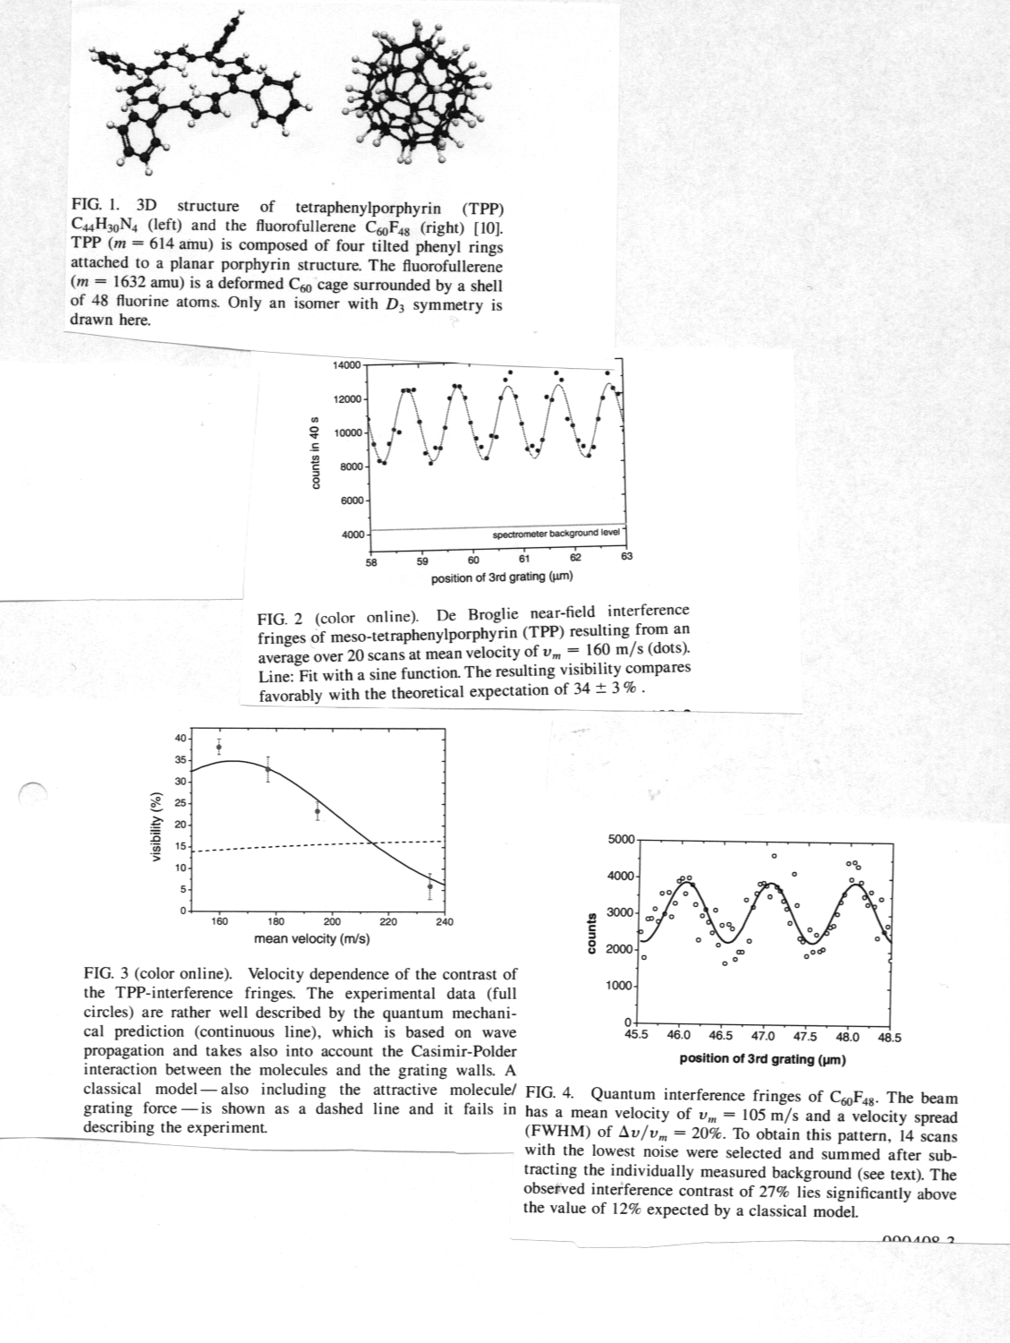

References

[1] L. de Broglie, Nature (London) 112, 540 (1923).
[2] I. Estermann and O. Stern, Z. Phys. 61, 95 (1930).
[3] C. Borde´, N. Courtier, F. D. Burck, A. Goncharov, and
M. Gorlicki, Phys. Lett. A 188, 187 (1994).
[4] W. Scho¨llkopf and J. P. Toennies, Science 266, 1345
(1994).
[5] M. S. Chapman, C. R. Ekstrom, T. D. Hammond, R. A.
Rubenstein, J. Schmiedmayer, S. Wehinger, and D. E.
Pritchard, Phys. Rev. Lett. 74, 4783 (1995).
[6] J. L. Clauser and F. Li, in Atom Interferometry, edited
by P. R. Berman (Academic Press, San Diego, 1997),
pp. 121–151.
[7] M. Arndt, O. Nairz, J.Voss-Andreae, C. Keller, G. van der
Zouw, and A. Zeilinger, Nature (London) 401, 680
(1999).
[8] M. Arndt, O. Nairz, and A. Zeilinger, in Quantum
[Un]Speakables, edited by R. Bertlmann and A. Zeilinger
(Springer-Verlag, Berlin, 2002), pp. 333–351.
[9] L.W. Bruch,W. Scho¨llkopf, and J. P. Toennies, J. Chem.
Phys. 117, 1544 (2002).
[10] S. I. Troyanov, P. A. Troshin, O.V. Boltalina, I. N. Ioffe,
L. N. Sidorov, and E. Kemnitz, Angew. Chem. Int. Ed. 40,
2285 (2001).
[11] K. Patorski, in Progress in Optics XXVII, edited by
E.Wolf (Elsevier Science, Amsterdam, 1989), pp. 2–108.
[12] J. F. Clauser and S. Li, Phys. Rev. A 49, R2213 (1994).
[13] B. Brezger, L. Hackermu¨ller, S. Uttenthaler, J. Petschinka,
M. Arndt, and A. Zeilinger, Phys. Rev. Lett.
88, 100404 (2002).
[14] B. Brezger, M. Arndt, and A. Zeilinger, J. Opt. B 5, S82
(2003).
[15] K. Hornberger, S. Uttenthaler, B. Brezger, L. Hackermu
¨ller, M. Arndt, and A. Zeilinger, Phys. Rev. Lett. 90,
160401 (2003).
[16] G. L. Perlovich, O A. Golubchikov, and M. E. Klueva,
J. Porphyrins Phthalocyanines 4, 699 (2000).
[17] O.V. Boltalina, V.Y. Markov, A.Y. Borschevskii, N. A.
Galeva, L. N. Sidorov, G. Gigli, and G. Balducci, J. Phys.
Chem. B 103, 3828 (1999).
[18] The mean visibilities of different scan series varied due
to uncontrolled external perturbations. The additional
error is comparable to the statistical one.

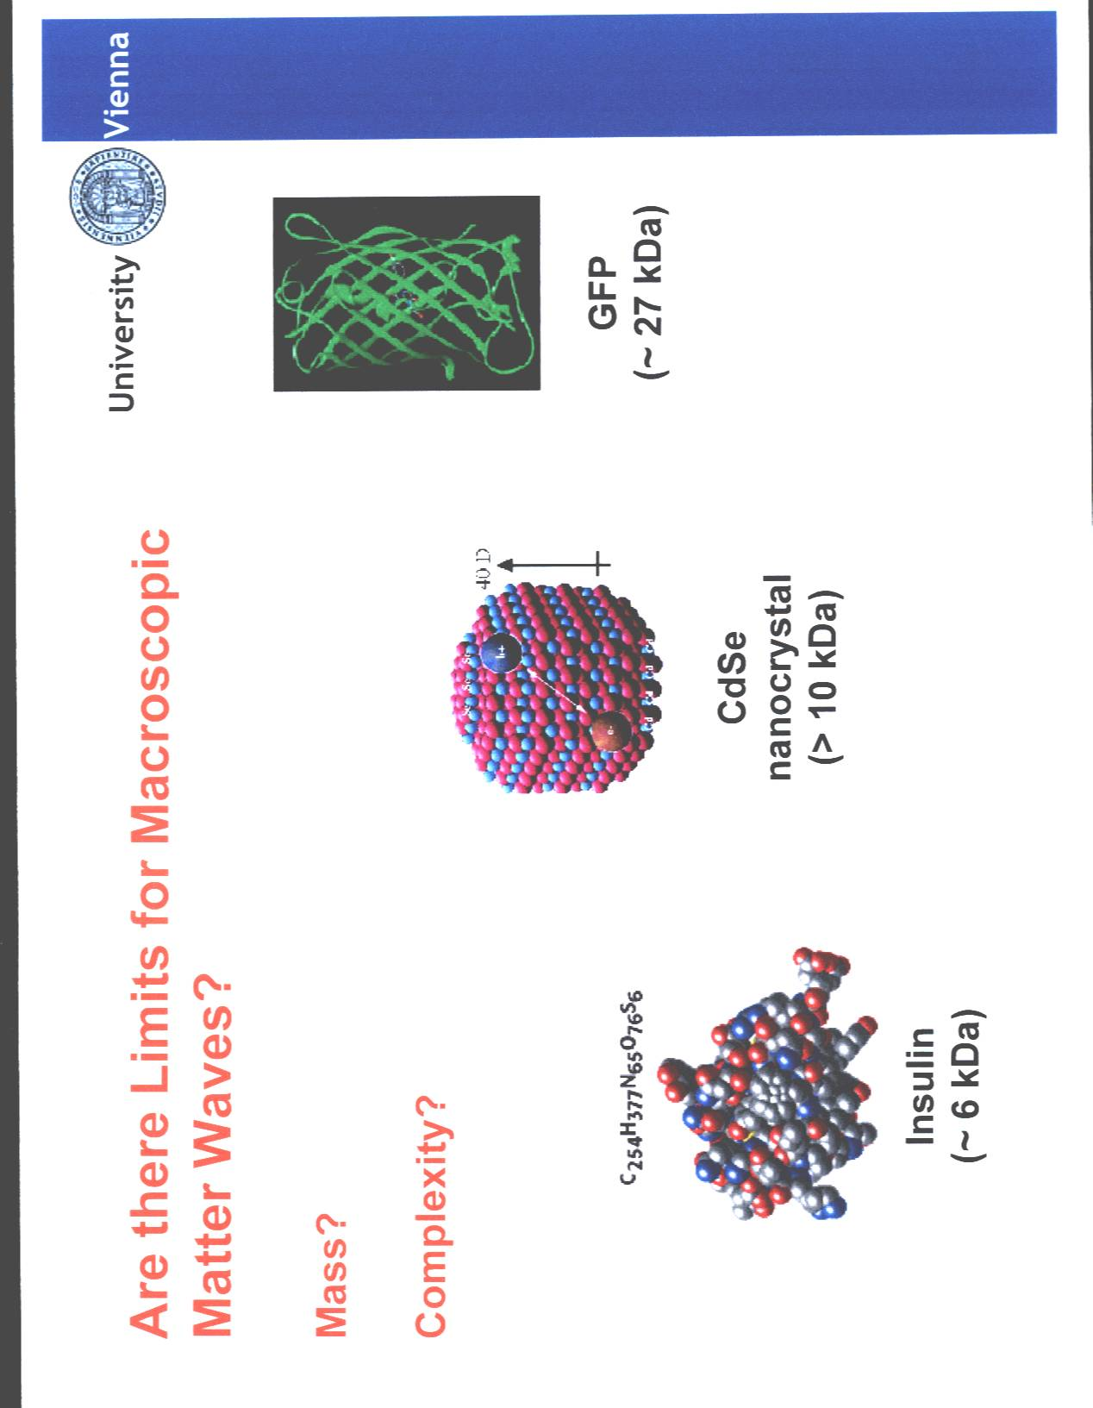

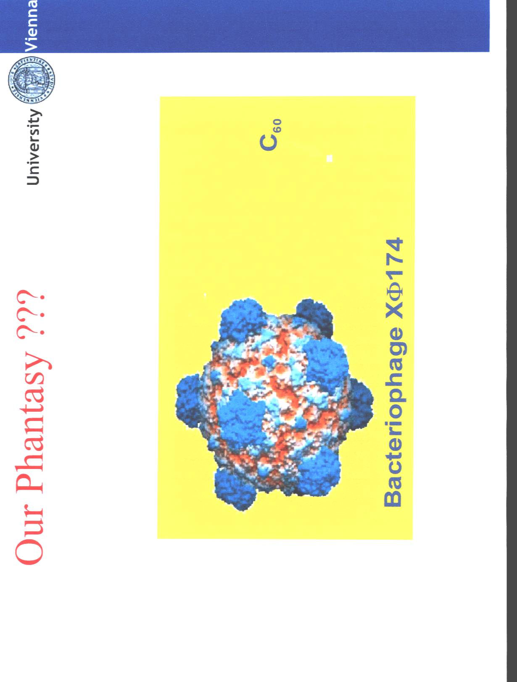



THE END

